# PRACTICAL 1

**AIM:** Creating and Managing vector data: Adding vector layers, setting properties, formatting, calculating Line length and statistics.

**Part-I: Adding vectors layers, setting properties, formatting.**

Step-1: Open QGIS→ Go to layers from toolbox → Create layers→ New shape file layers.

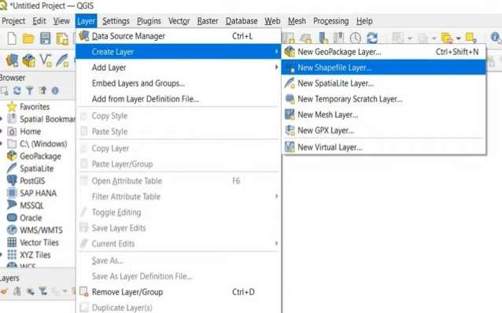

Step-2: New shape file layers → File name = NAME OF AREA, Encoding system = SYSTEM or UTFS, geometry type= POLYGON, Name=MALAD, Type =TEXT→ Add to field list →

OK.

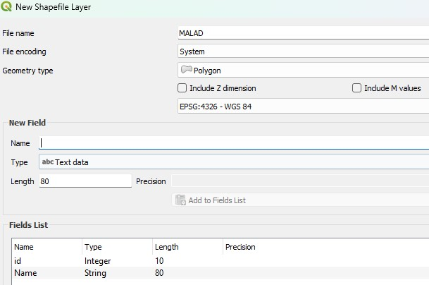

Step-3: Click on Toggle Editing→ Click Polygon →Draw on display window→ Right click on it to give Name → Malad =RSET→ OK.

Step-4: Draw two more polygons and give them name.

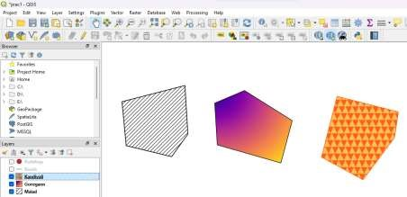

Step-5: Create layers→ new shape file layers →File Name= ROADS, Geometry type=LINE Name ROADNAME→ Add to field list →OK.

Step-6: click on toggle editing→ click line →Draw on display window→ right click on it to give name→ road name= ROAD 1 Step-7: Draw two three roads.

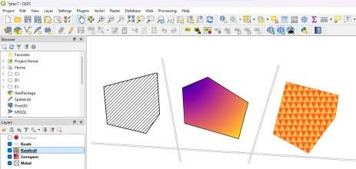

Step-8: Create layers→ New shape file→ Layers → file name= GSC, Geometry type= POINT ,Name: GSC NAME → Add to filed list→ OK.

Step-9: Right click on it and give A Name →

Step-10: Add two three buildings

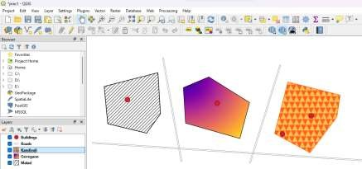

**Formatting:**

Go to layers (left bottom corner side of the windows) → Right click on it→ properties.

|  |  |  |
| --- | --- | --- |
| GOREGON | MALAD | KANDAVALI |

Output:

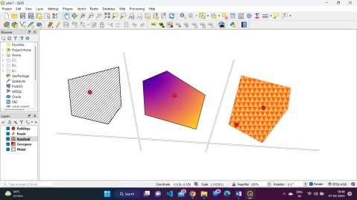

**Part-II Calculating time lengths and statistics.**

Step 1: Open QGIS → Go to layers→ Add Layers → Add Vector layers → Sourcevector datasets(s) (…) Click on three dots → Browse the file →Open IND_adm folder → IND_admo.shp file → Add → close → (India outline map will be added).

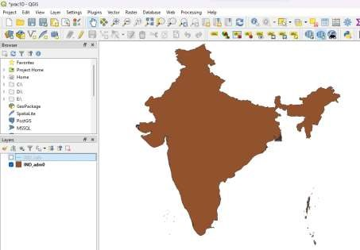

Step 2: Add another layer

Add layer → Add vector layer → (…) click on three dots → Browse the file

→ Open IND_rails.shp file → Add → close

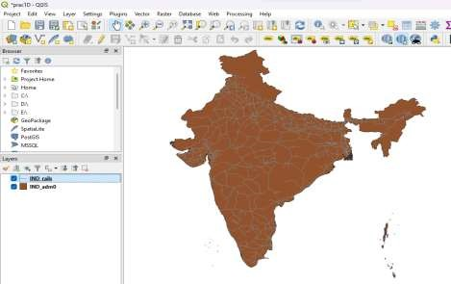

Step 3: Right click on IND_rails → open attribute table..

(We have to add one more attribute in this table)

Step 4: Click On Toggle Editing button

|  |
| --- |
| Track_len2 |

Step 5: Click on open Field calculator Output field name :

|  |
| --- |
| Decimal number real number |

Output field type :

$Length / 1000

|  |
| --- |
|  |

Write the formula the above formula (we are dividing by 1000 as we are getting larger value So we convert from M to KM)

|  |
| --- |
|  |

→ Click on OK  button

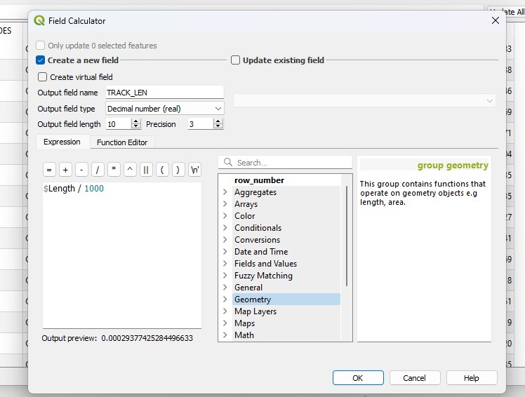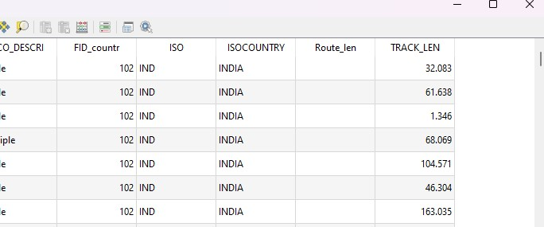

Step 6: Vector → Analysis tools → Basic Statistics for fields

(Note: I want to perform statistics on rail . by default we are getting rail_map)

Field to calculate statistics on.

|  |
| --- |
| Track_len2 |

=

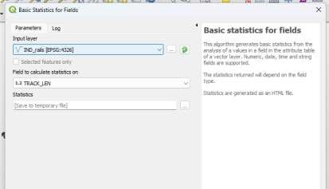

Step 7: Click on Run.

Step 8: Close it.

Step 9: Select the link (.html file) from Right button corner.

Output:

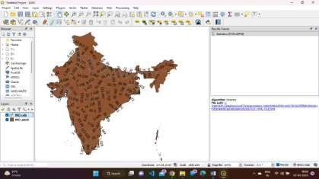

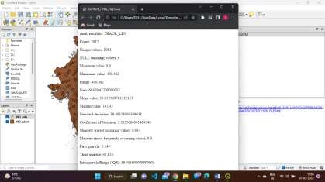

**PRACTICAL 2**

Exploring and Managing Raster

**Prac 2 a) Adding Raster Layer**

Step 1: Layer - Add layer - Add Raster Layer - … (three dots) --(ADatagl_gpwv3_pdens_90_ascii_one- glsq90ag60.asc) - Add - Close

Layer - Add layer - Add Raster layer- …(three dots) (A-Data-gl_gpwv3_pendens_ 00_ascii_one-glds00ag60.asc)

**Note: It’s in gray scale (pixel format)**

Output:

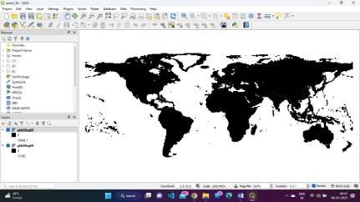

1. **Raster Styling And Analysis**

Eg: ( We have to find an area where population has been changed between year 1990 to 2000)

(Largest Population Change)

Now we have to convert gray scale image into colour format.

|  |
| --- |
| Singleband pseudocolor |

Step 1: Right click on glds90ag60 --properties-- Render type

|  |
| --- |
| Continous |

Min Max 240 , mode -- classify -- Apply - OK.



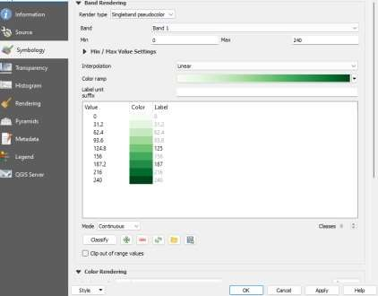

|  |
| --- |
| Singleband    pseudocolour |

Step 2: Right Click on glds00ag60 -- properties -- Render type

|  |
| --- |
|  |

Min O  Max 240  , mode Continous  -- Classify -- Apply-- OK .

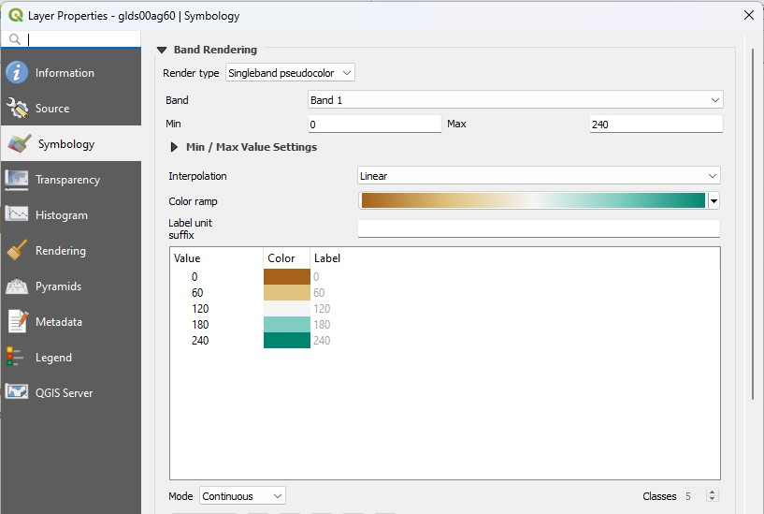

Output:

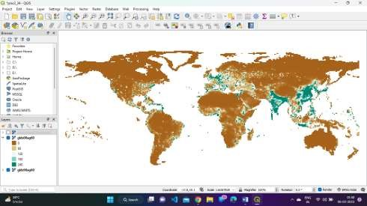

1. **Analysis.**

Step 1: Menu -- Raster -- Raster Calculator.

Output Layer : Population_Difference

|  |
| --- |
| GeoTIFF |

Output Format:

|  |
| --- |
|  |

Click On …  to save layer ( C:\GIS \ pract2\Population_Difference)

Step 2: Select the first layer (glds00gs60@1) － select the second layer (glds90gs60@1)

Raster Calculator Expression glds00ag60@1 - glds90ag60@1

Output CRS : Project CRS : EPSG: 4326 -

WGS84

→ OK.

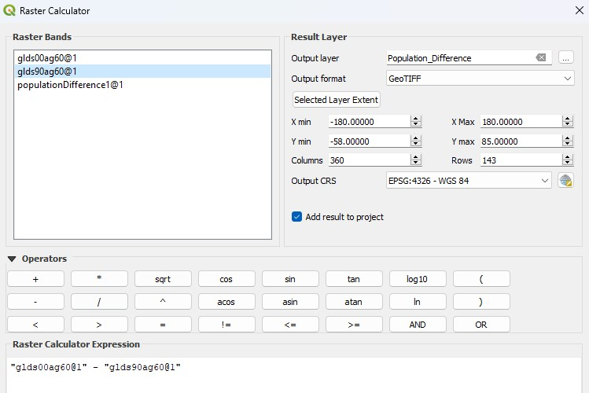

Step 3: Select population difference ☑ -- Right click on -- properties.

Render type : Singleband pseudocolour  , min -20,000

|  |
| --- |
|  |

|  |
| --- |
| 6000 |

max ,

|  |
| --- |
|  |

Interpolation . Discrete , Colour Map, Awy

|  |
| --- |
| － |

Select all value color label usinng shift and then click on

|  |
| --- |
|  |

Click on ＋  and Given page

-20000 No Data

-10 Negative

10 Neutral

6000 Positive

|  |
| --- |
| vivids |

Color rmap

→ Apply → OK

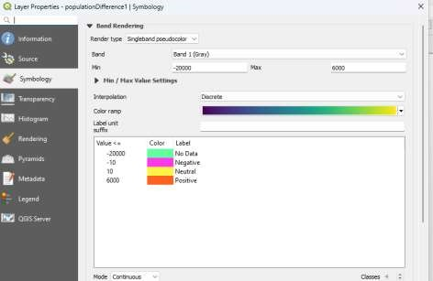

Step 4: Click on i from menu (we can verify classification)

Output:

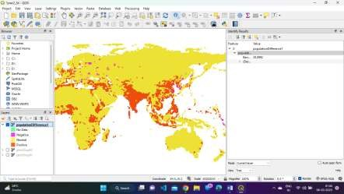

**D] Raster mosaicking and Clipping**

Raster Mosaicking and clipping A mosaicis a combination or merge of two or more images. In GIS a single raster datasheet can be created from multiple raster datasheet be mosaicking them together.

we can combining two raster, datasheet – Mosaicking we are creating.

Step 1: Layer -- Add layers -- Add raster layers -- (…) -- A -- (FAS – India 32018350. Terra 367.2km FAS India 2018350 terra 367.2km) -- open -- add -- close.

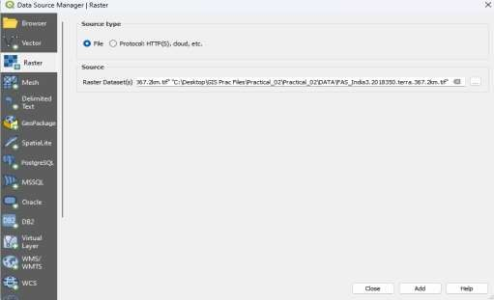

Step-2: Raster -- Miscellaneous -- Merge input layer -- Check all layer click on SELECT ALL -- Run -- close.

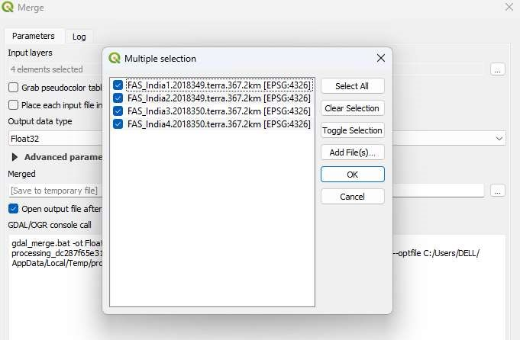

Step-3: Dis-select All the layers (uncheck) select only merger -- From layers panel.

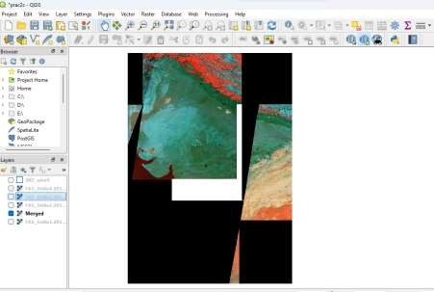

Step-4: Layers -- add Layers -- Add vector layers (…) -- (India admin boundary --INDadm0shp) -- Add -- Close.

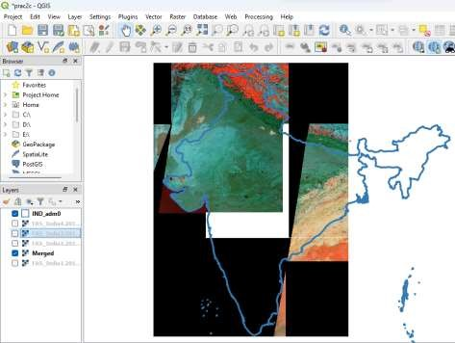

Step-5: Double click on the IND-Adm0 (should be checked-----) -- Symbology --Apply -- OK.

Step-6: Raster -- Extraction -- clip Raster by Mask layers. Input layer MERGED(EPSG:4326)

Mask layer IND-adm0(EPSG:4326) -- Run -- CLOSE.

Output:

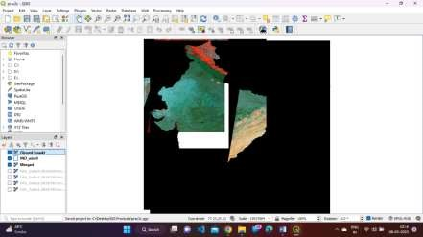

**PRACTICAL 3**

Prac 3 a) Making a thematic map using print layout

Step I: Layer -> Add Layer -> Add vector layer

1: (Practical 03-> A -> India_State_Admin -> IND_admi.shp) -> Add

2: ( “ A -> maharashtra_administrative -> maharashtra_administrative.shp) -> Add 3: ( “ A -> maharashtra_coastline -> maharashtra_coastline.shp) -> Add

4: ( “ A -> maharashtra_highway -> maharashtra_highway.shp) -> Add 5: ( “ A -> maharashtra_location -> maharashtra_location.shp) -> Add 6: ( “ A -> maharashtra_natural -> maharashtra_natural.shp) -> Add

7: ( “ A -> maharashtra_poi -> maharashtra_poi.shp) -> Add

8: ( “ A -> maharashtra_water -> maharashtra_water.shp) -> Add

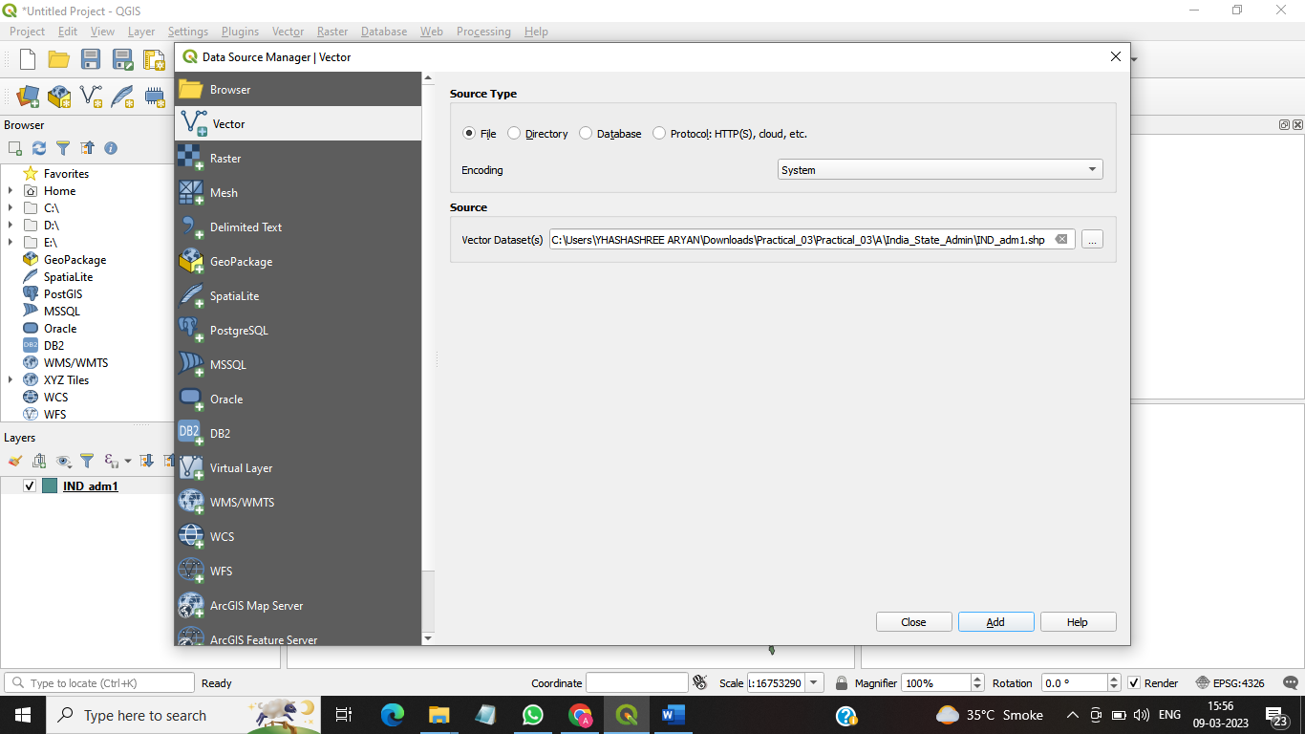

Step 2: select IND_adm1.shp from layer panel -> right click ->properties -> colour -> outline green.

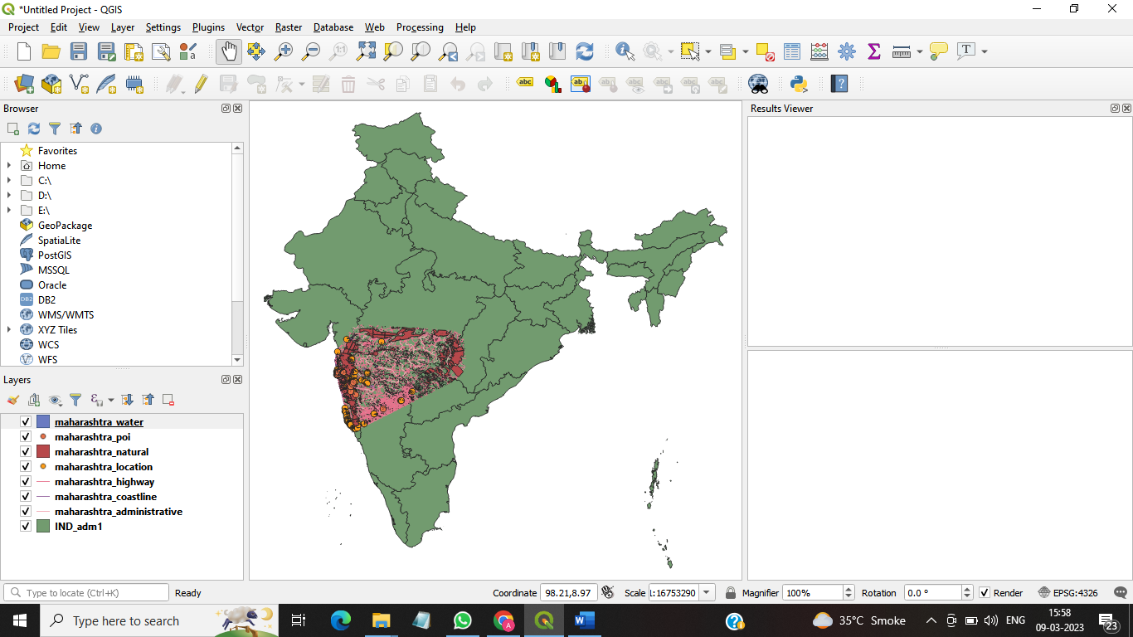

Step 3: select maharashtra_poi.shp from layer panel -> right click ->properties -> colour -> dot ed

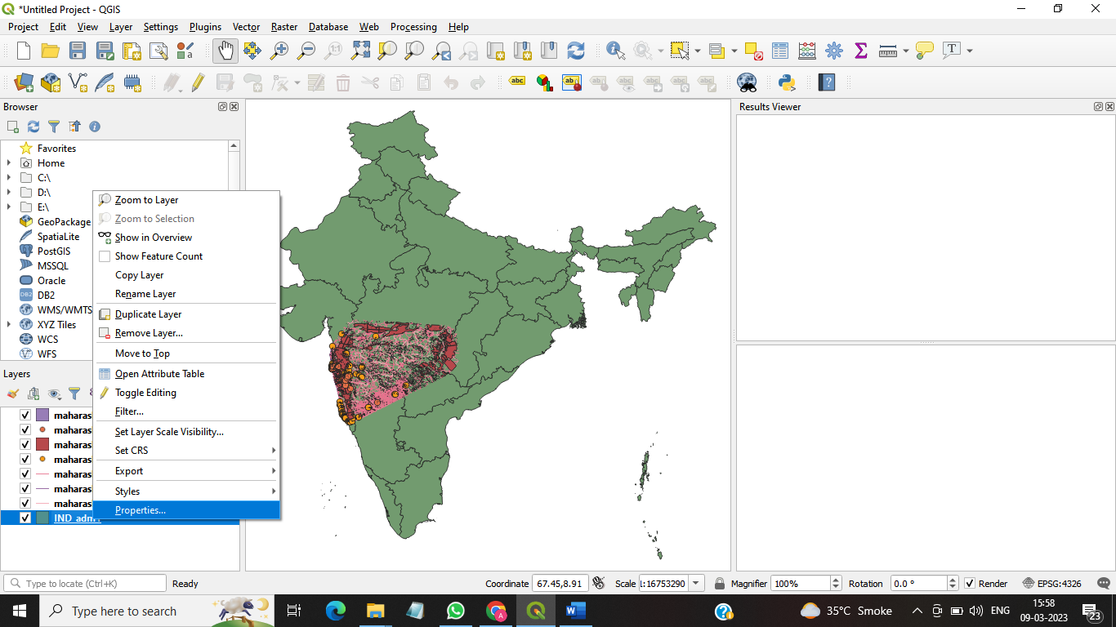

Step 4: Project -> new print layout ->(Practical 3a)-> ok-> add item->add map-> (select the white area -> drag & drop (map will appear Right side of the window) item properties -> check the lock Styles for Layers) 

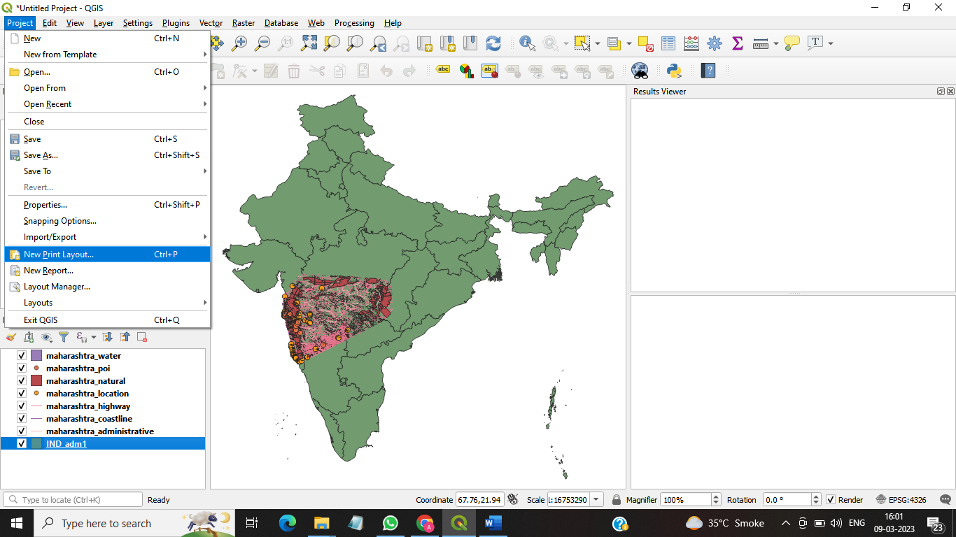

Step 5: go to the main window(Don't close the back window) -> zoom it & focus on Mumbai region

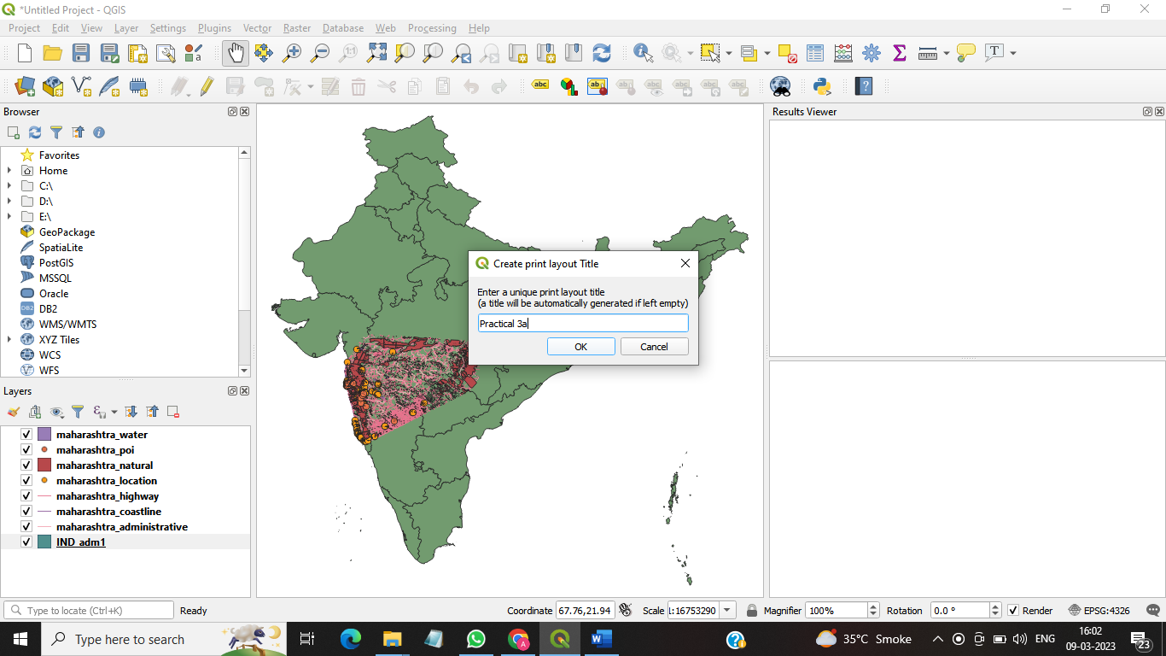

Step 6: Go back to the back window(Practical 3A). ADJUST THE POSITION

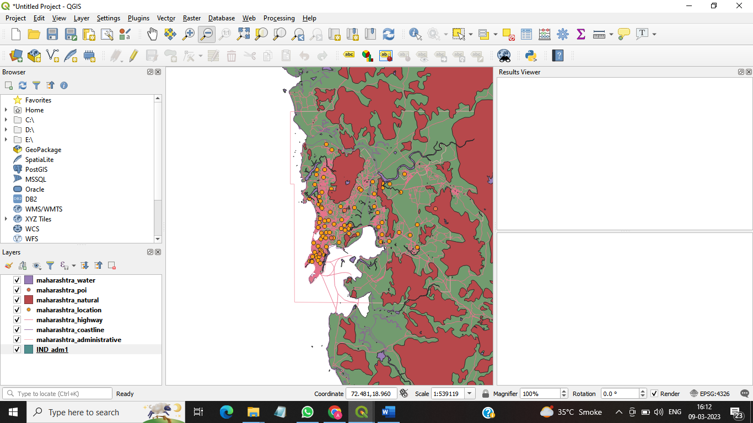

Step 7: add item -> Add Map

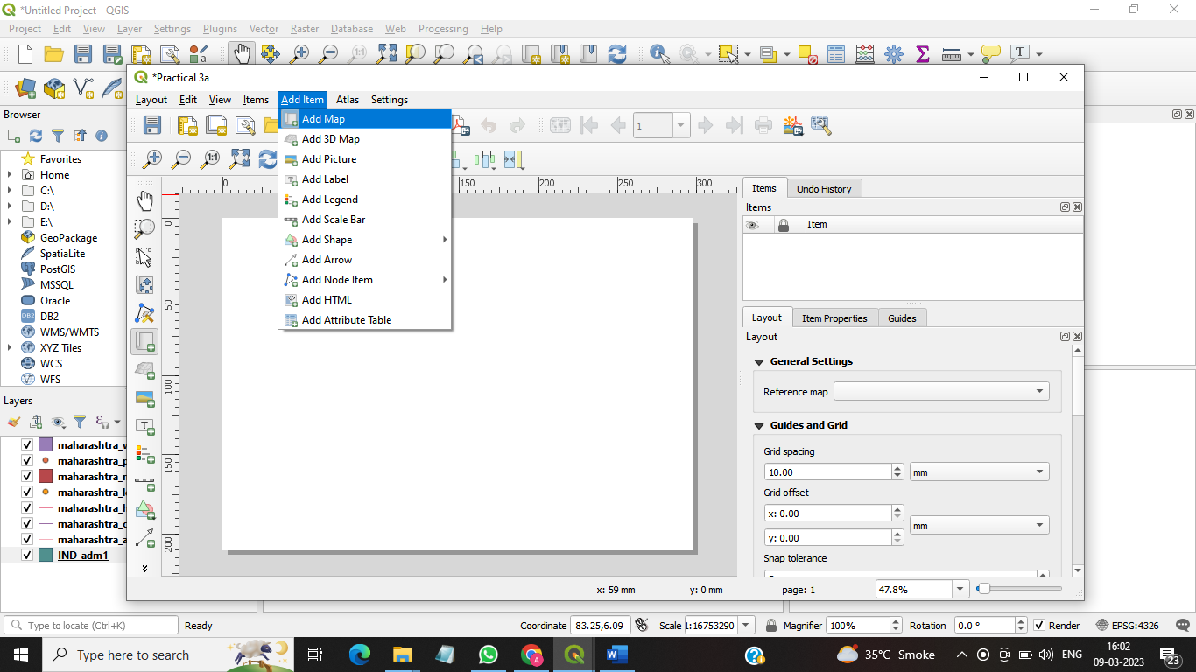

Step 8: right side of the window-> select map1 from Items-> right click properties

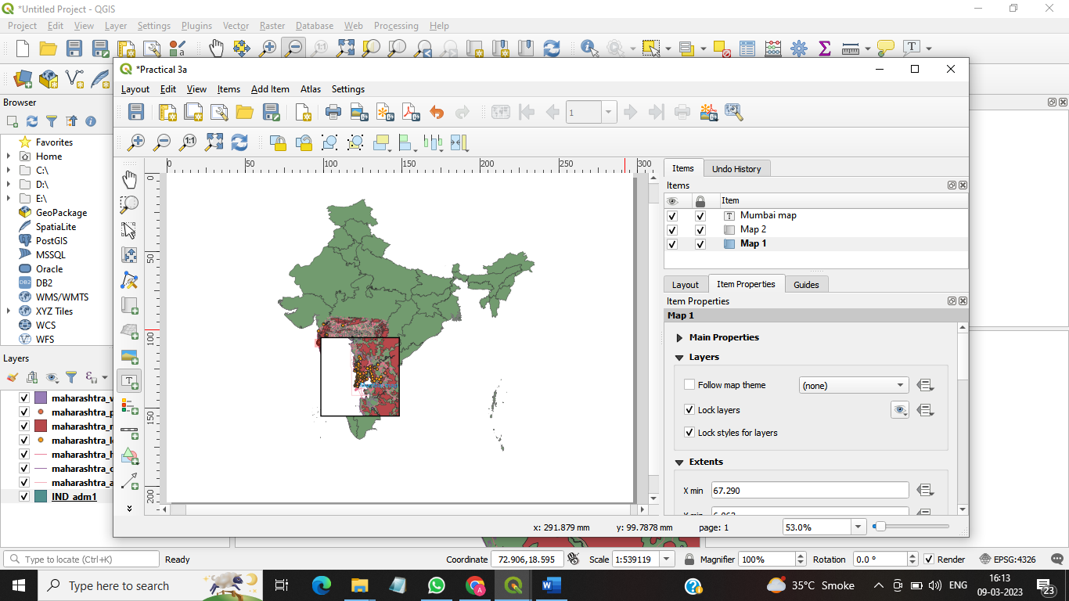

Step 9: go to the Item properties-> Overviews-> click on + -> select Overviews 1 -> select Map Frame (map 2)

Step 10: select map2 from items-> right click on properties-> Frame (  )-> colour black-> Thickness 0.70

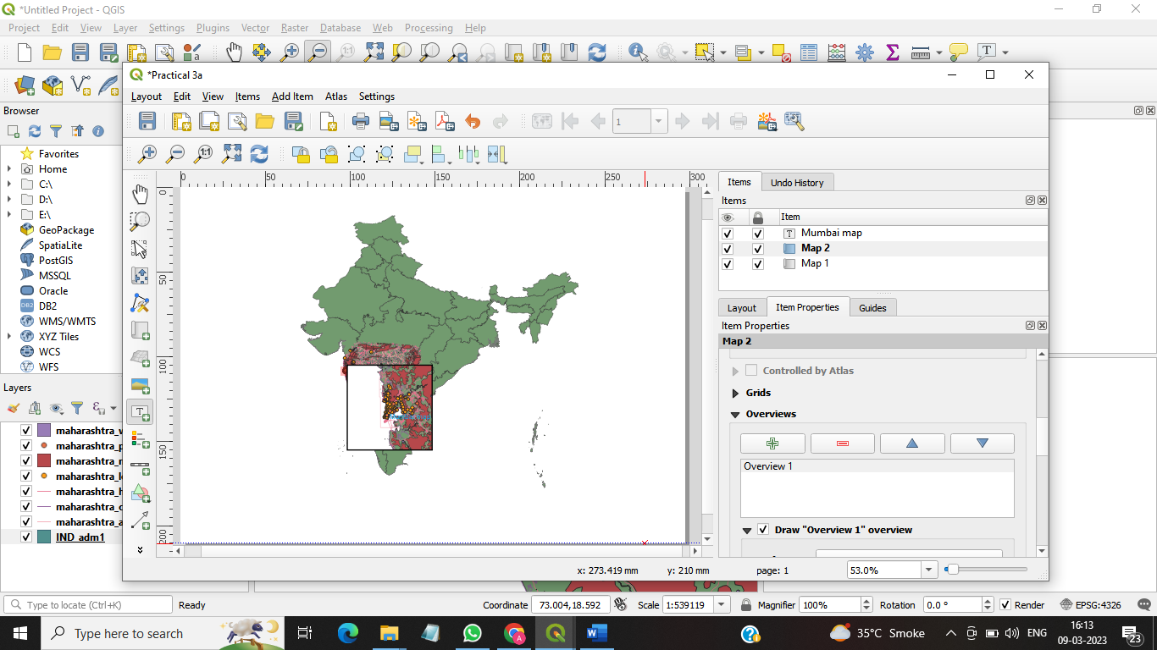

Step 11: add item-> Add label-> select the region-> go to the right side of Item properties-> give name as Mumbai map-> we can change the font, color, alignment, rotation,etc.

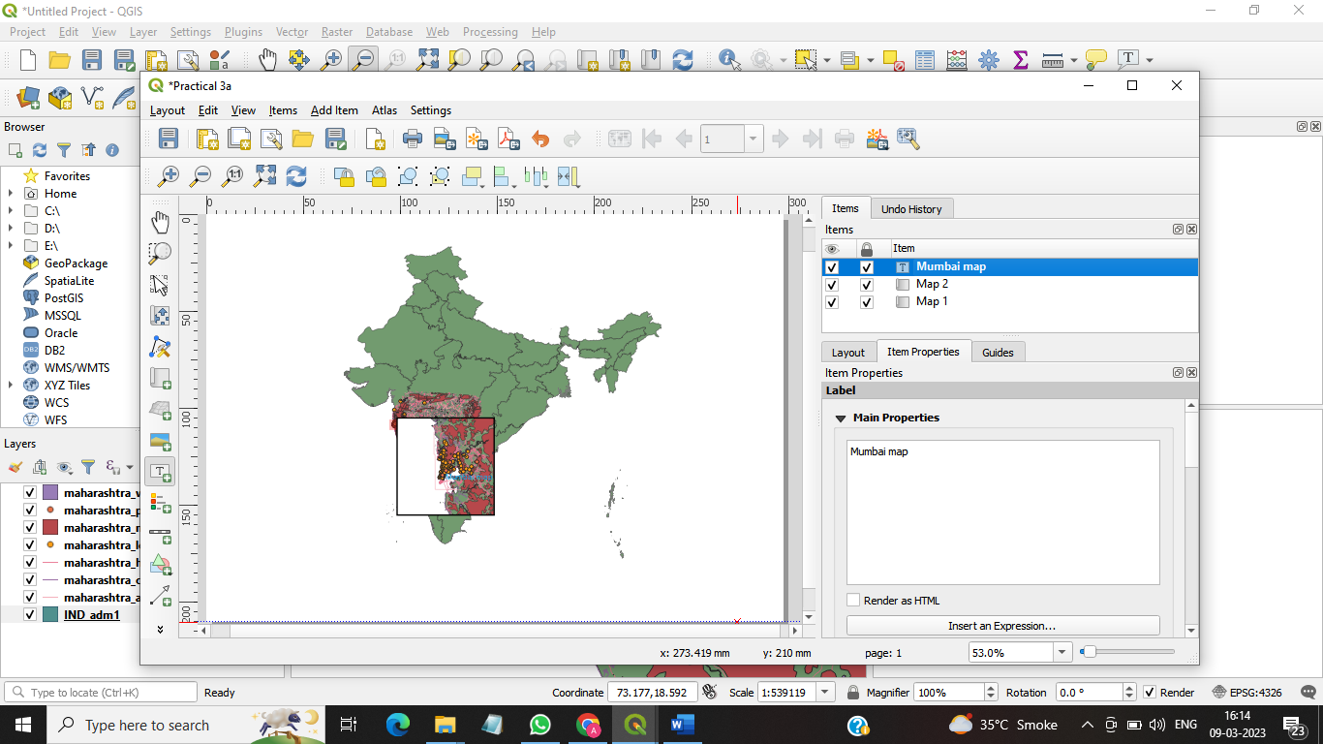

Step 12: add item-> Add label(now we are adding copyright symbol) So we will right some html code -> go to item properties-> <h2>&copy; Copyright Reserved </h2> <h1>Saraf college</h1> Check the Render as HTML (You can change the color, font , alignment)

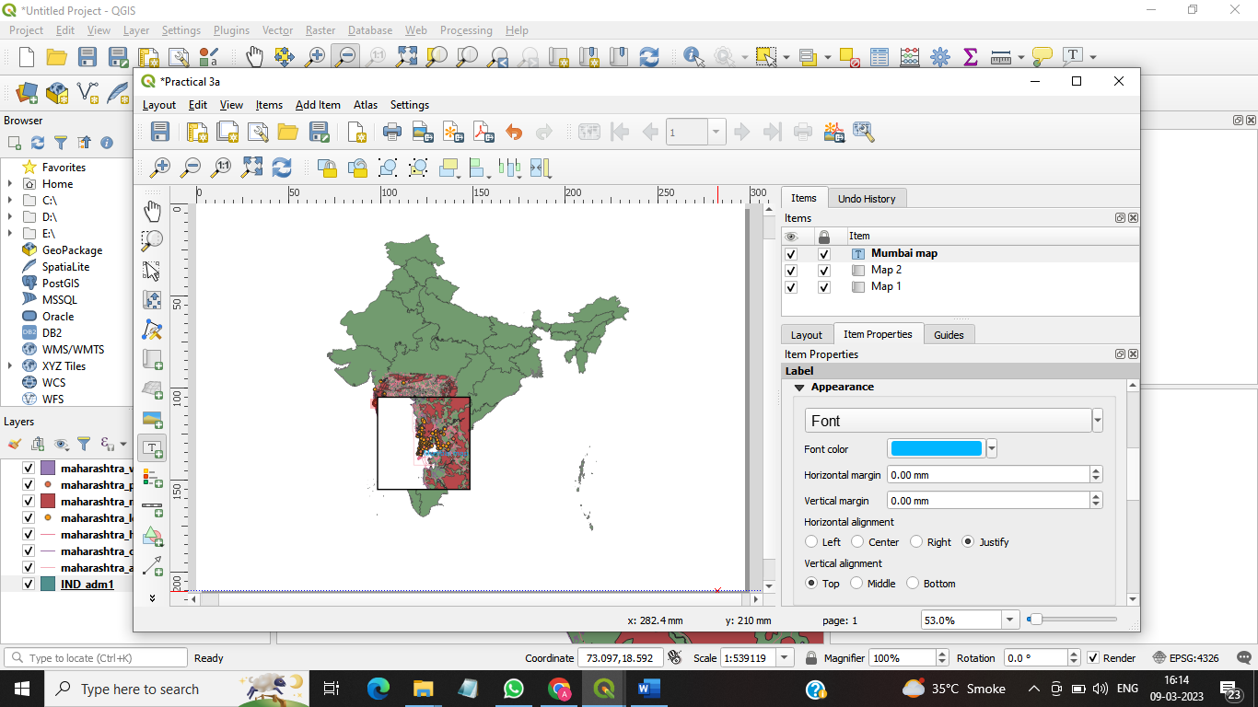

Step 13: add item-> Add legends-> (all layer will appear in the window)-> go to the properties-> item properties-> legend items-> auto update (deselect it )

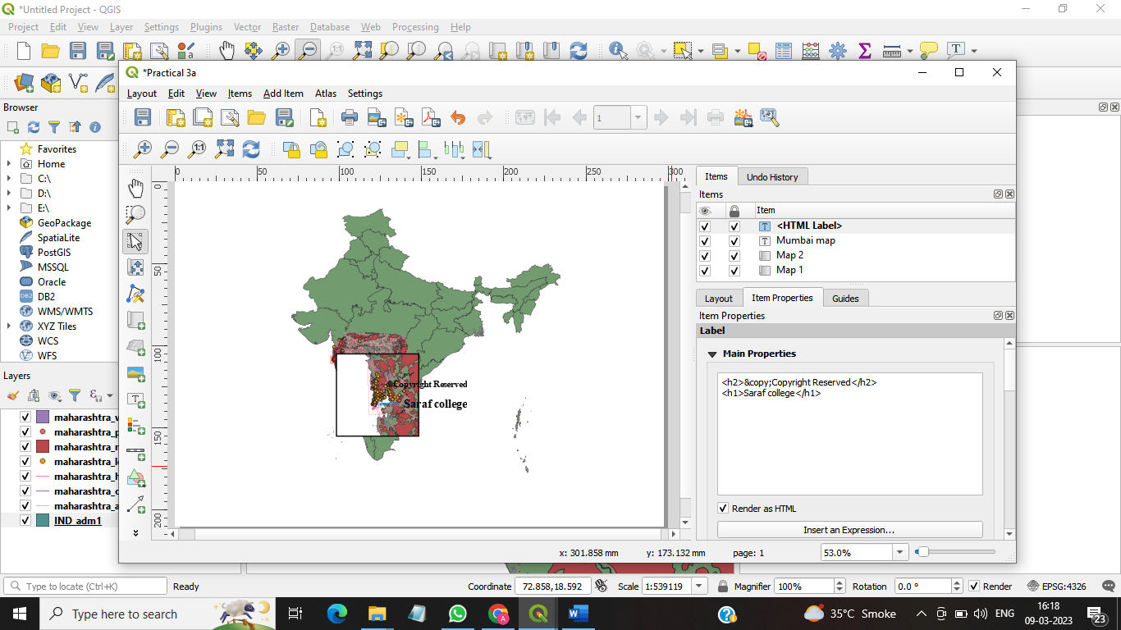

Step 14:double click on maharashtra_water from auto update-> change it to [water]. You can change the colour-> custom symbol (check it) -> change it to blue colour (same way we change other layer)

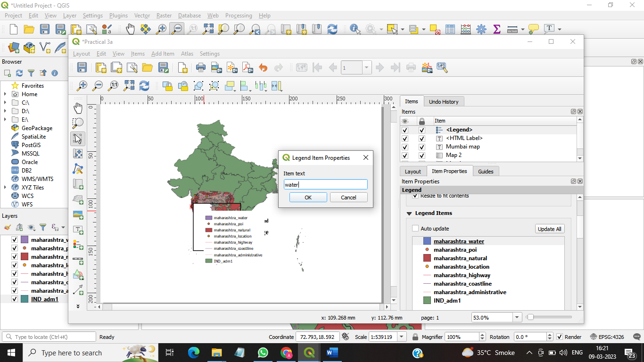

Step 15: add item-> Add scale bar-> Item properties-> Segments-> right 10(from where to start)

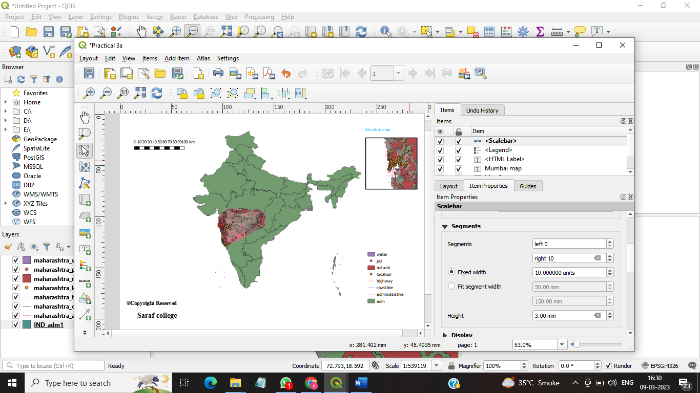

Step 16: add item-> Add North arrow(we can show the orientation)-> item properties-> svg images

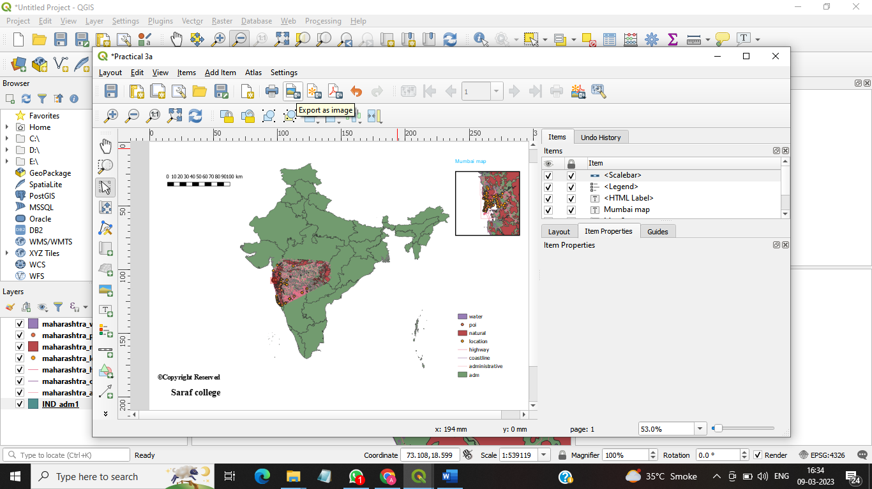

Step 17:layout -> Export as image(.jpeg)-> file name prac 3a (already given)-> Save resolution [600 dpi] -> save.

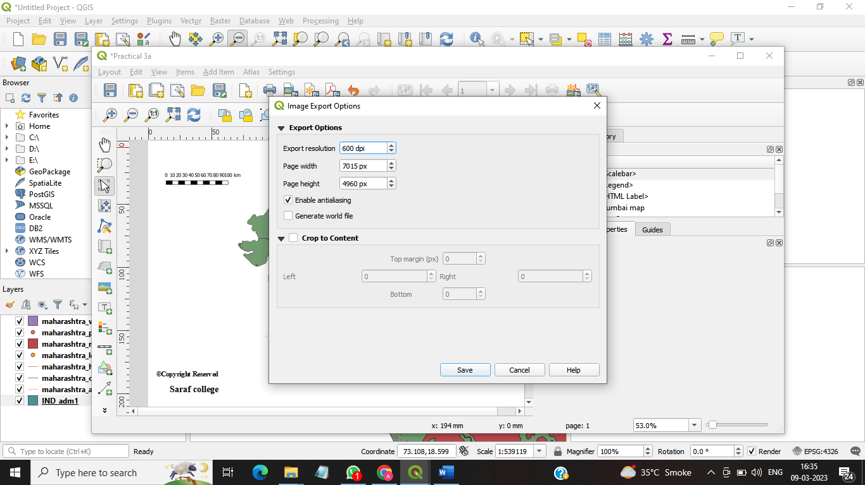

Prac 3 b) Importing spreadsheets or csv file

Step 1: layer-> add layer-> add delimited text layer File name: (practical_03-> data -> sample.csv-> open)

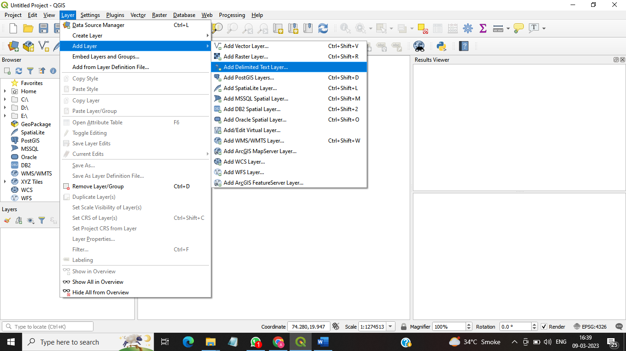

File format (  tab)

Check for longitude & latitude value X field longitude

Y field latitude

Geometry CRS– EPSG:4326-WGS 84-> add -> close

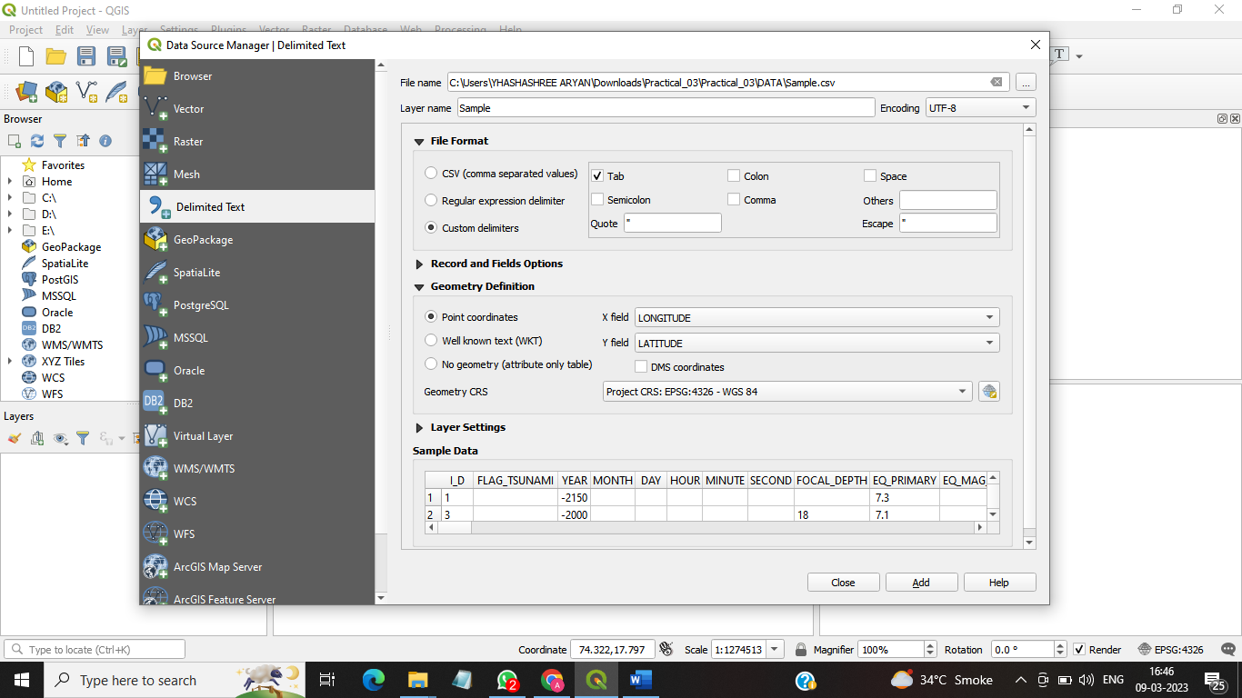

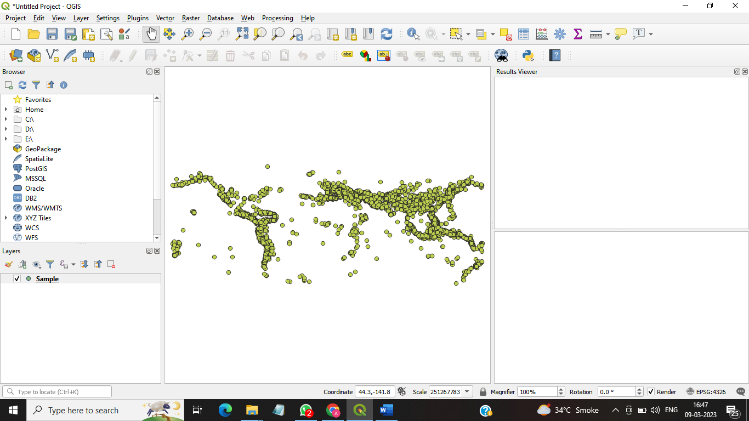

Practical-3C,D

Step 1: take a new file-> plugins-> manage and install plugins-> search for [OSM place search]

-> select osm place search-> click on install plugins -> search for openLayer plugins -> click on install experimental plugin.

(We can see in plugin options -> osm place search & web -> open layers plugin)

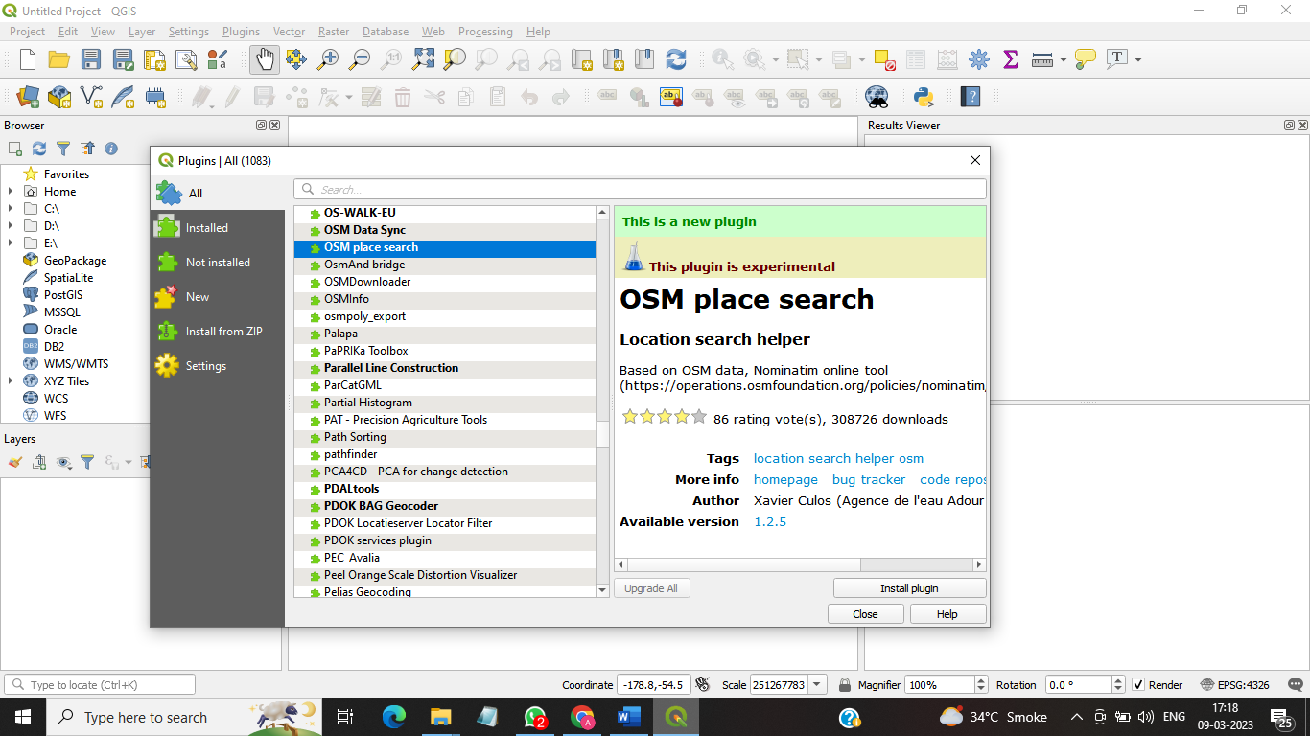

Step 2:web-> open layers plugins -> openStreetMap-> openStreetMap

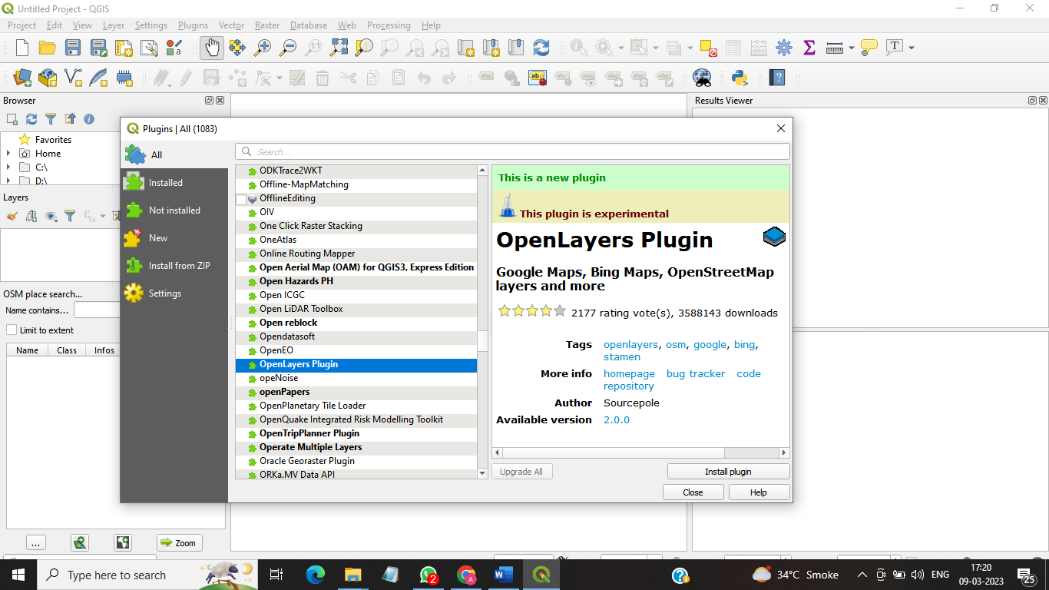

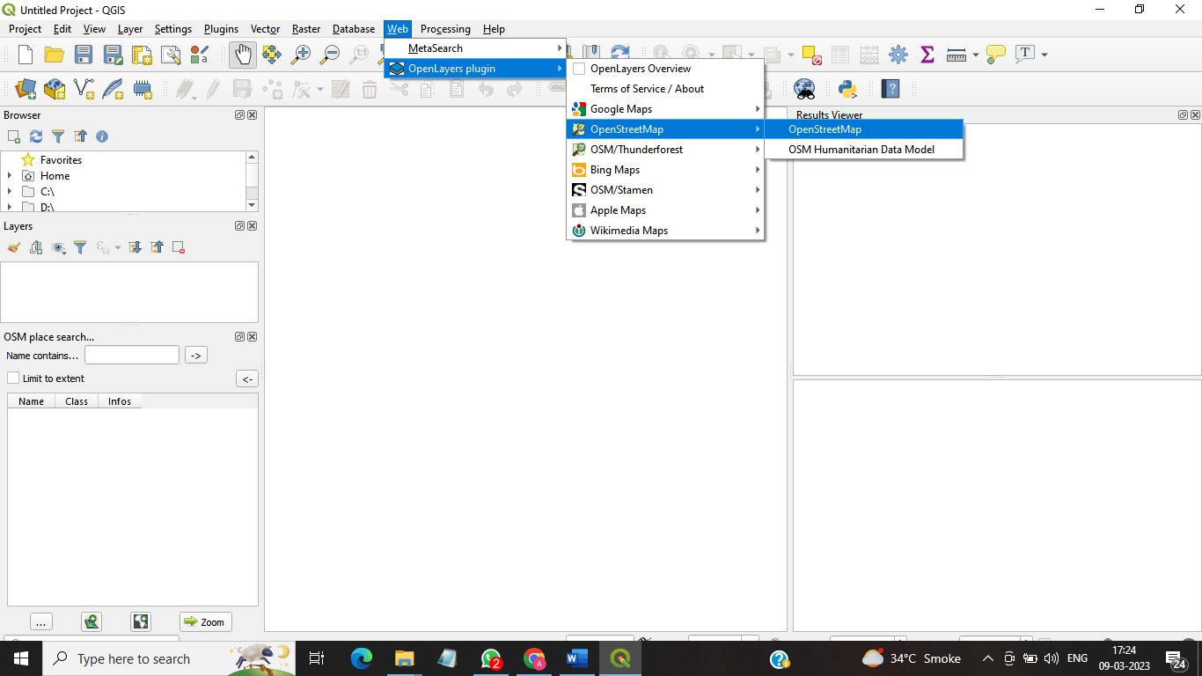

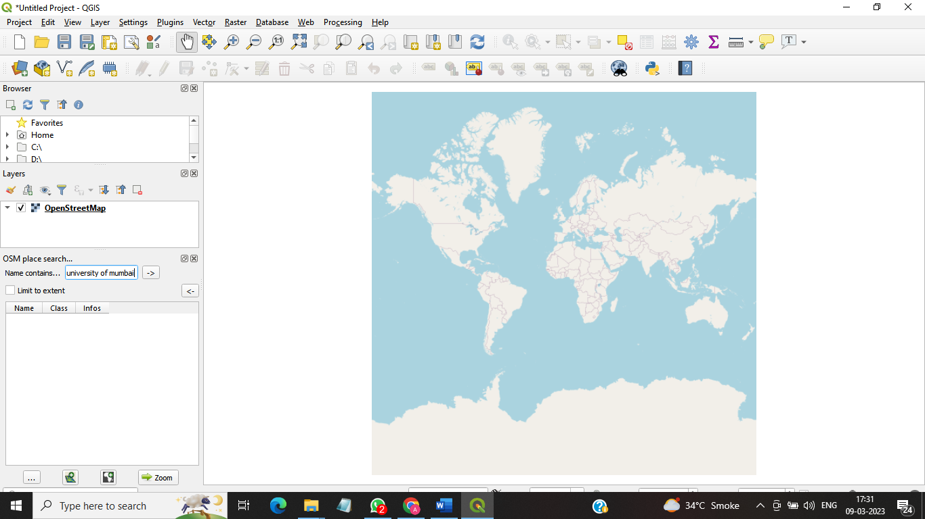

Step 3: go to the left side of the panel-> name contains-> university of mumbai-> click on (->) -> select bharti vidyapeeth deemed university department from the list-> click on zoom.

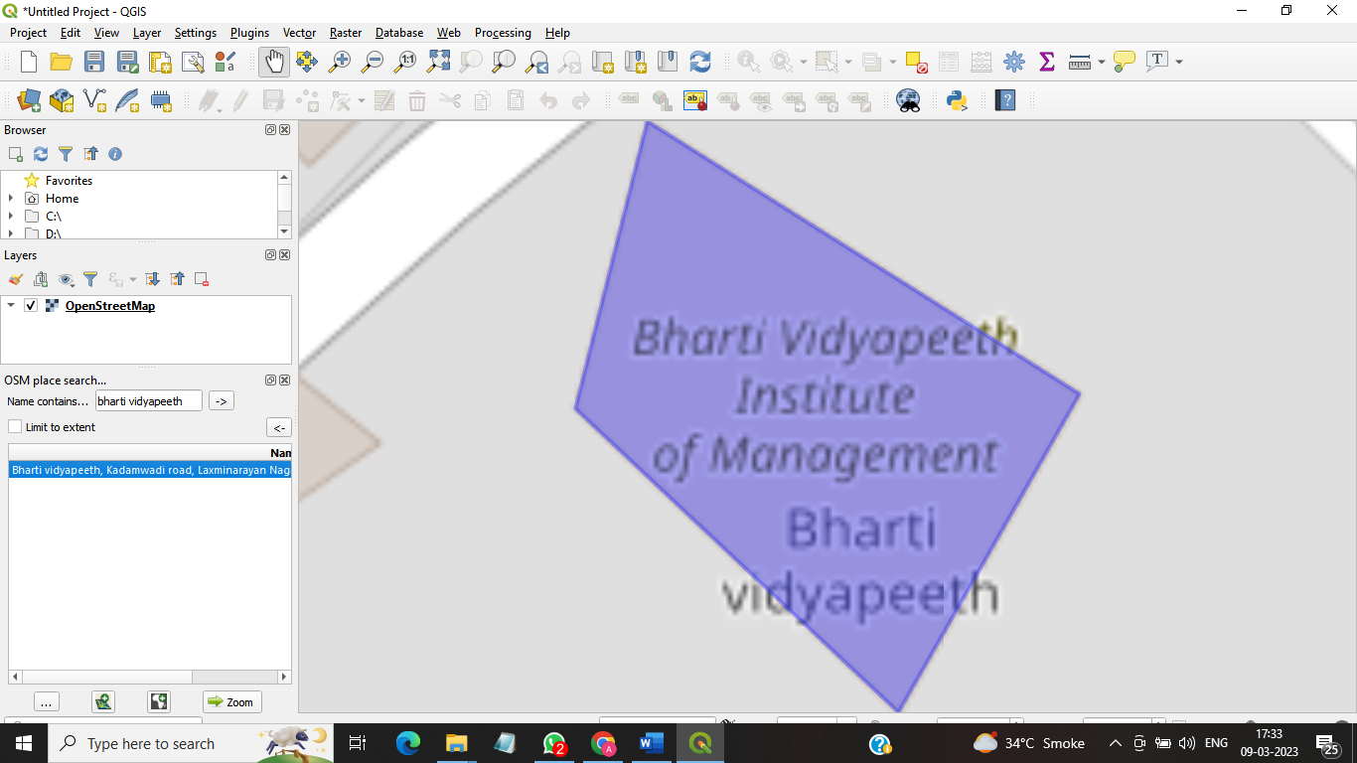

Practical : 4A-

Pract 4 a) working with attributes.

**Step I:**

Layer → Add Layer 🡪 Add vector Layer🡪 Select **(Practical_04🡪A→ne-10m_populated_places_Simple.zip )**🡪 Add🡪 close.

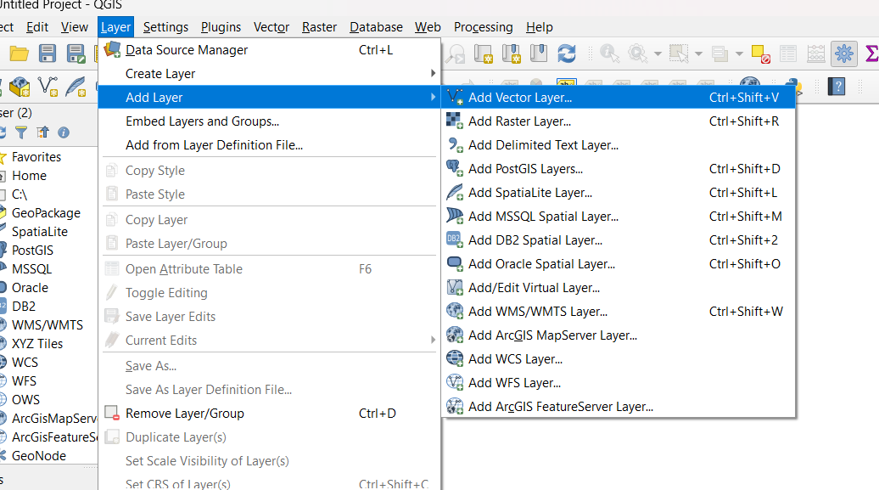

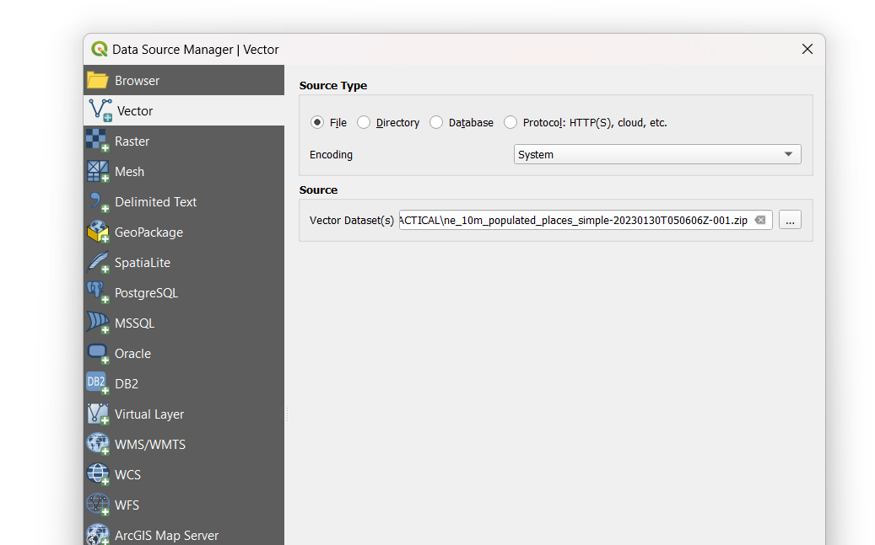

**Step II:**

Right click on layer ne-10m-populated_places_Simple🡪 Open attributes tables **(search for pop-max column)** click on first value of pop-max 🡪 Select 🡪 Select **[E.]** select features using an expression (you will get a new window) →Type Expression pop-max > 100 and pop-max <1000 **(so we are searching for places which have population between 100 & 1000**) 🡪Click on select features button → click on close button 🡪close the window.

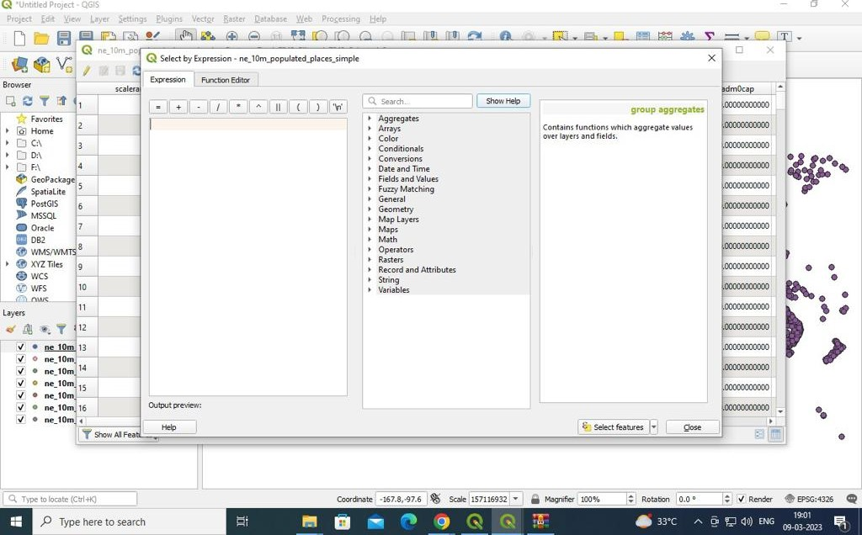

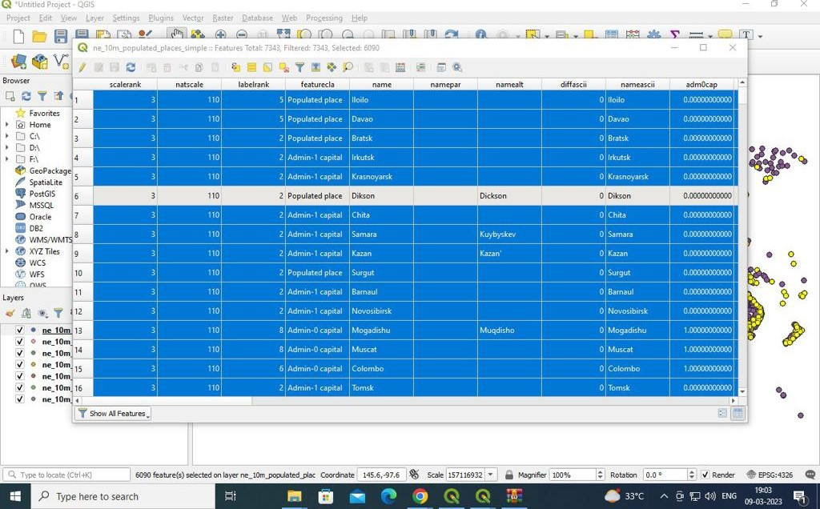

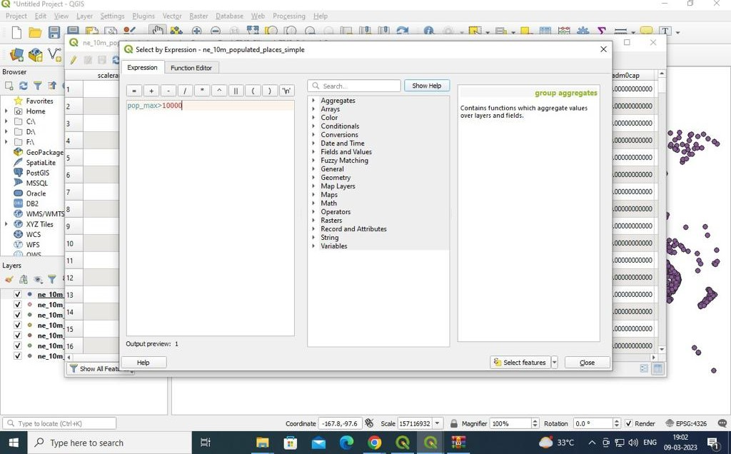

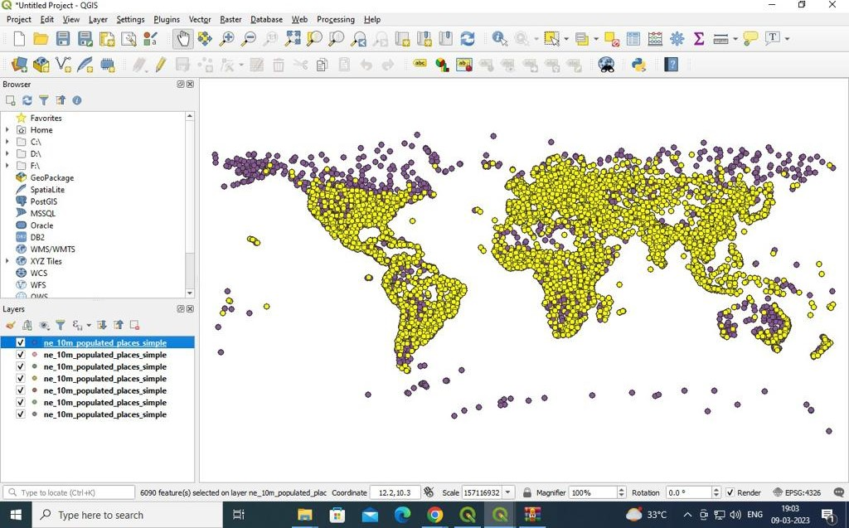

Prac 4 b) Terrain Data & Hill shade Analysis (Geographical Surface)

A terrain dataset is multiresolution, TIN-based Surface built from measurements stored as features in a geodatabase. Terrain or elevation data is useful for many GIS analysis like to generate various products from elevation date such as contours, will shades etc.

(We represent high / extreme low) elevation, mountains, slops TIN- Triangular Irregular Network (It's vector based. geographic data) we use Series of number to represent TIN

Hill shade is a gray scale 3D representation of the surface, showing the topographical shape of hills & mountains using shading (levels of gray) on map, just to indicate relative slopes, mountains ridges, not absolute height.

Eg. upper regions indicated by light shader & lower region indicated by dark shade.

**Step-1 :-** Layer 🡪Add layer🡪 Add raster Layer 🡪 **[…] (Practical_04_Data → GMTED 2010N10E060_300 🡪 10n060e-2010 1117_gmted-mea300.tif)** 🡪 Add🡪 close (lower region is dark & upper region is light).

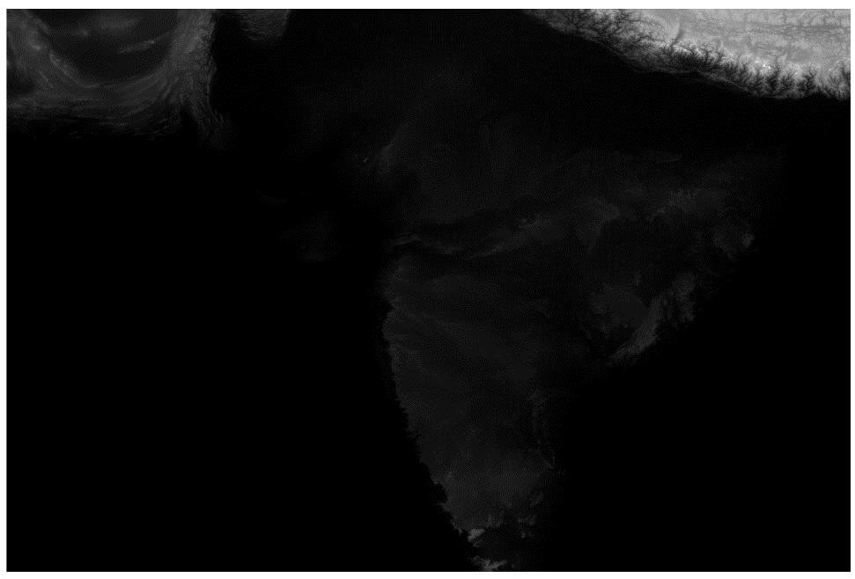

**Step-2 :-** Change the coordinate. We have to set the co-ordinate of Mt. Everest. change it to 86.92, 27. 98. Change the scale to 1:900000 magnifier is 100 % .

**Step-3 :-** Raster🡪 Extraction 🡪clip Raster by Extent (As we are interested Mt. Everest area) 🡪 **[Input Layer ][10 n060e - 20101117_grited_mea 300.][EPSG: 4326]** 🡪Clipping extent**: […] [Use deep Canvas Extent]**🡪 Clipped **[…] [Save to file] [clippedhimalaya )** .tif **( type**)🡪save 🡪Run 🡪Close.

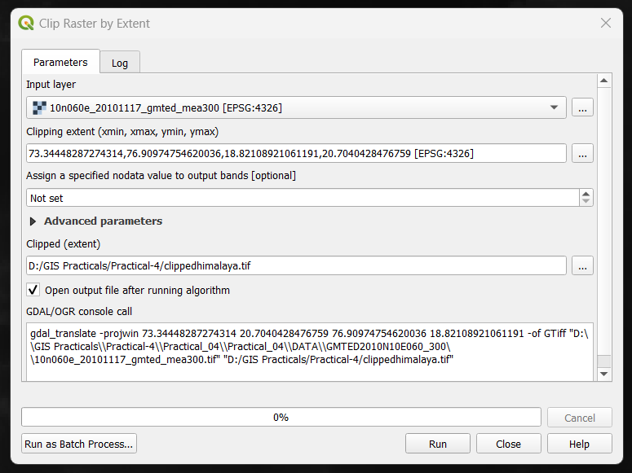

**Step-4 :-** Disselect the 10n060e-2010111-7-gmted_mea300.tif Raster 🡪Extraction🡪Contour 🡪Interval **[100.0000000]** 🡪 Contours **[…] save to file [Contourhimalaya]**.gpkg [**type**] 🡪save 🡪Run🡪close**(Input**

**layer should be clippedhimalaya [EPSG: 4326])**

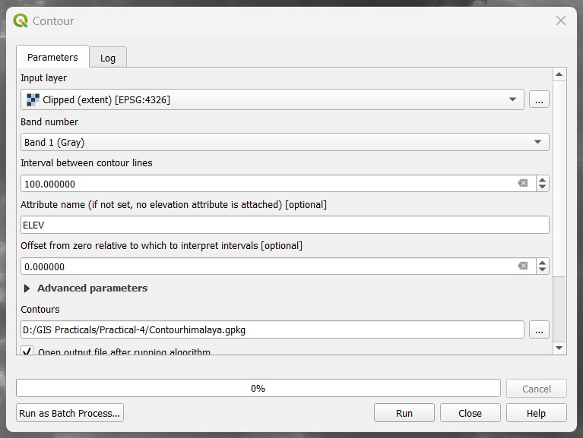

**Step-5 :-**Now we are going to show (elevation)

Right click on Contourhimalaya 🡪 properties 🡪 Labels →**[Single Labels]** →value **[1.2 ELEV ]** → color **[red]** → Apply → OK.

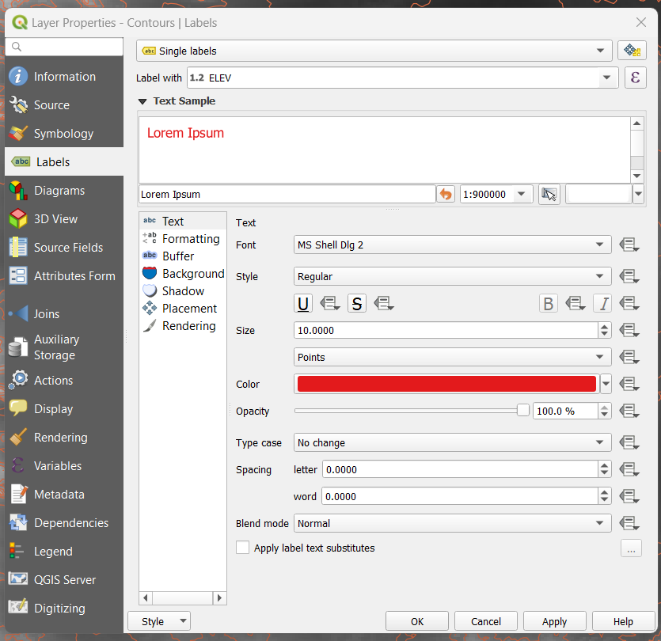

**OUTPUT :-**

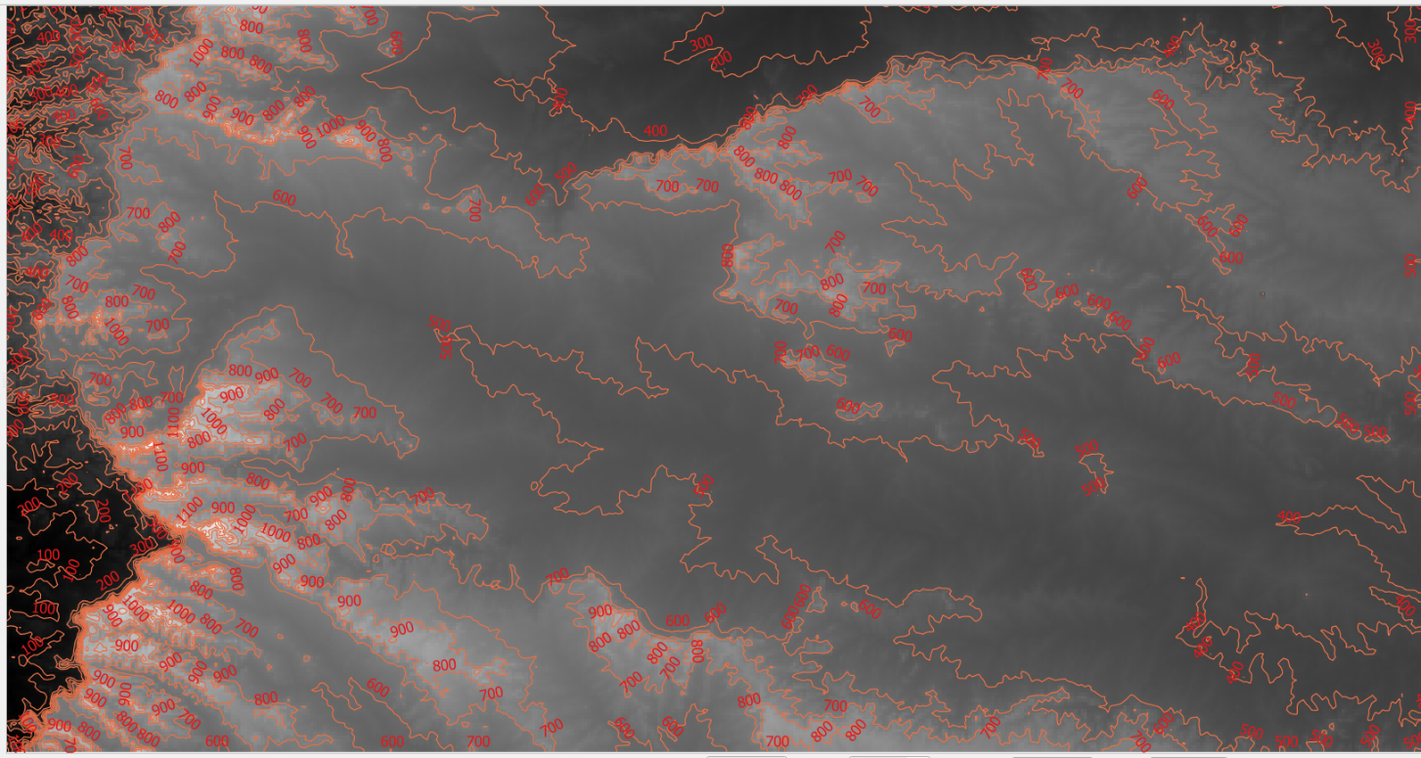

Practical 6

Prac 6A Georeferencing Topo sheets and Scanned maps

Step 1: Layer -> Add Layer →Add vector Layer ->[…] (Practical_6A_ Georeferencing_Toposheet >IND_admo→INDadm0.shp) → Add → close [ Focus on Mumbai →zoom it out]

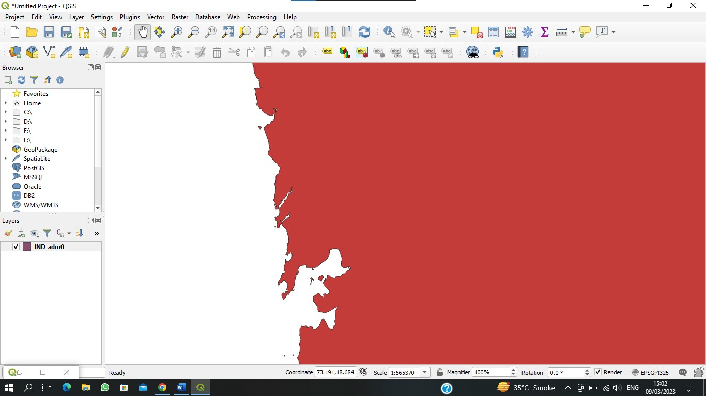

Step 2: Raster -> Georeferencer [ File > Open Raster -> Bombay_1909.jpg] We have added co-ordinates. We are adding

Three co-ordinates. Enter map co-ordinates [put the point on original map] -> From map canvas. → Click on original map

→ ok. File -> start Georeferencing Settings -> Transformation settings Transformation type [Thin Plate spline]

Resampling method [Nearest neighbour] Target SRS [EPSG:4044-unknown datum based upon the Everest 1830

EPSG:4044] ->OK

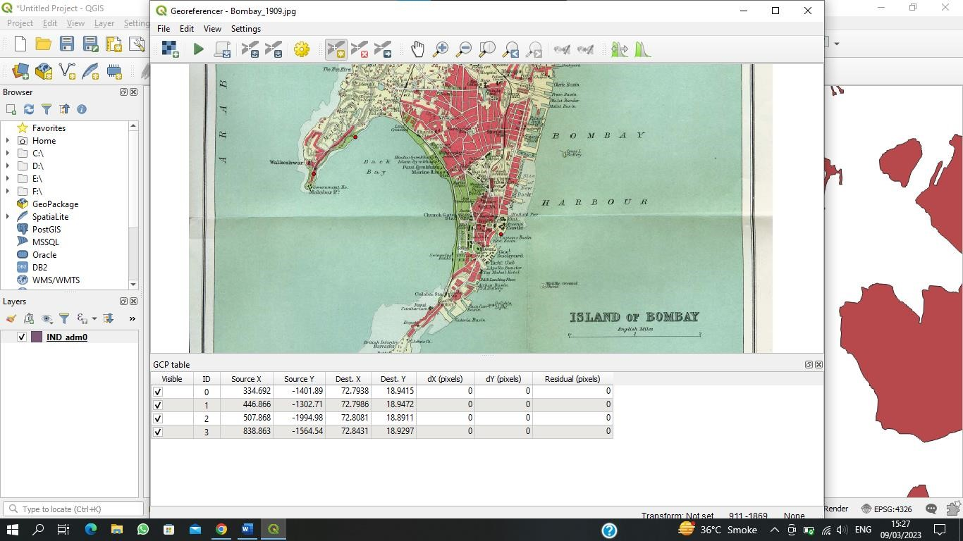

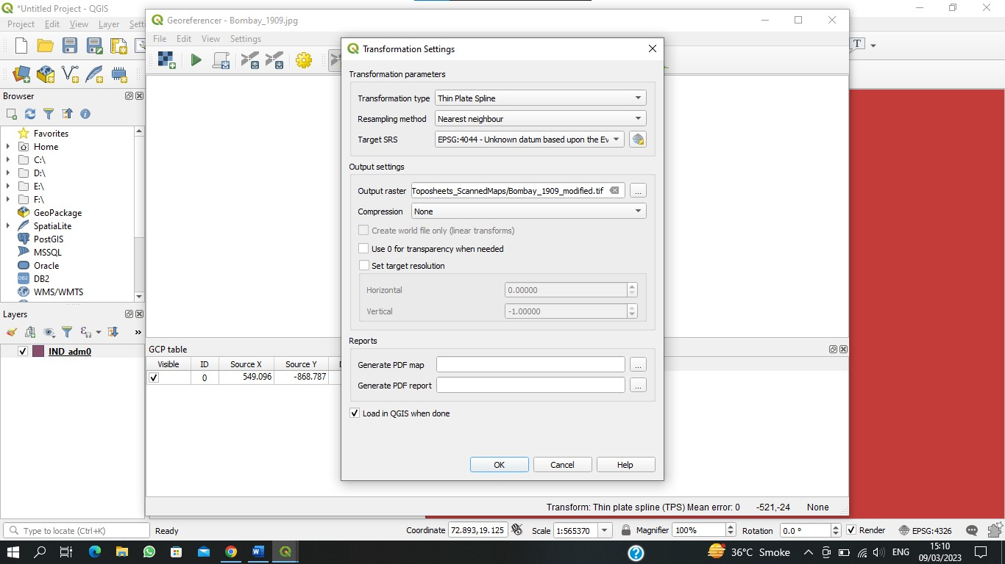

Step3: close the Georeferencer → save → replace it yes

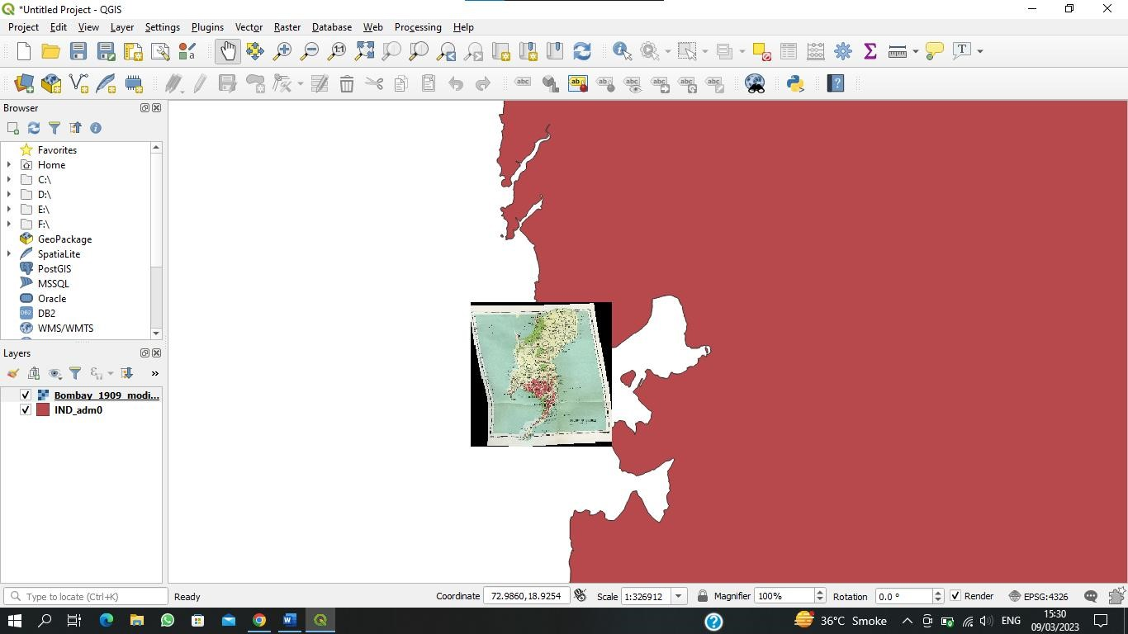

Step 4: Right click on Bombay_1909_modified -> properties -> Transparency -> Global opacity 32.0 % [Output: we have mapped the image on a vector layer which is called georefrencing]

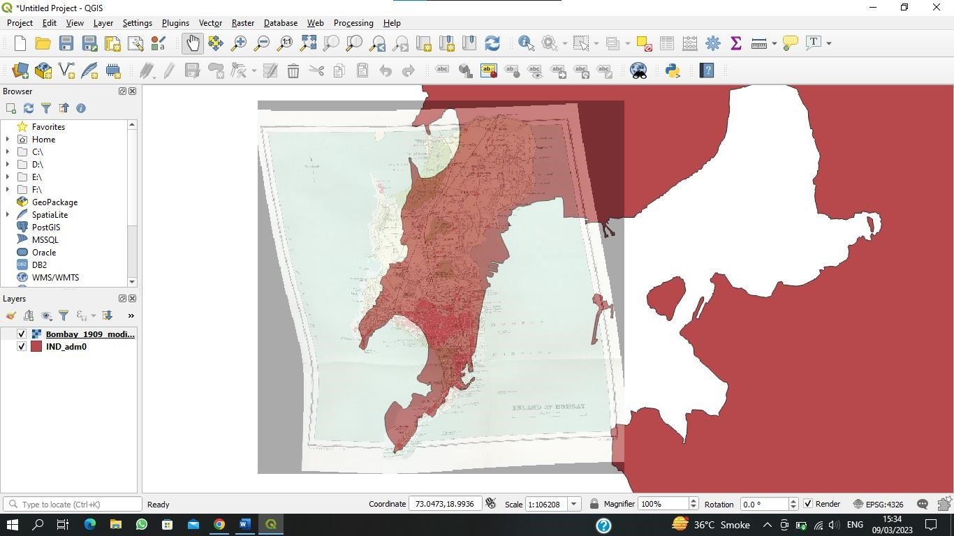

Prac 6b- Georeferencing Aerial Imagery

[Check for openlayers plugin & openstreetmap]

Step 1: Web -> openLayers plugin -> OpenStreetMap -> OpenStreetMap

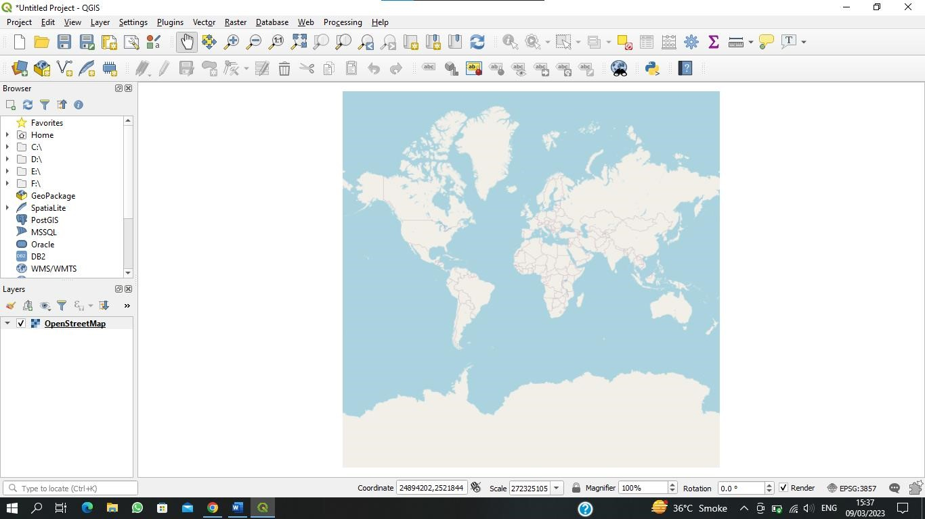

Step 2: Project -> Properties -> CRS -> [WGS 84/Pseudo Mercator EPSG:3857]-> Apply-> OK

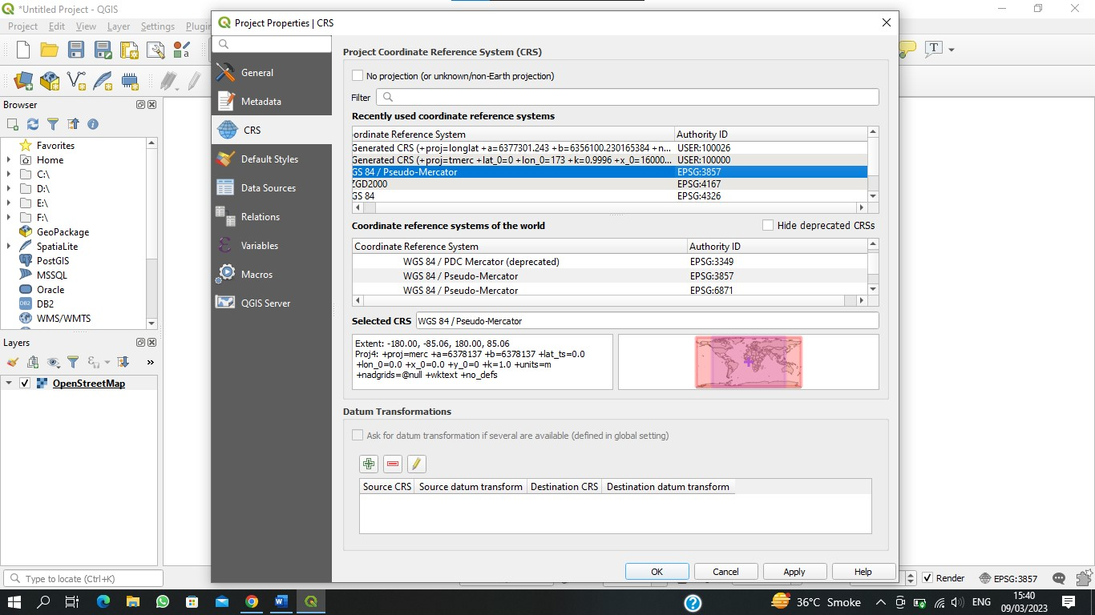

Step 3: View-> Panels-> OSM Place Search [ ](select it) OSM place search -> Name contains [Washington Square Park] zoom

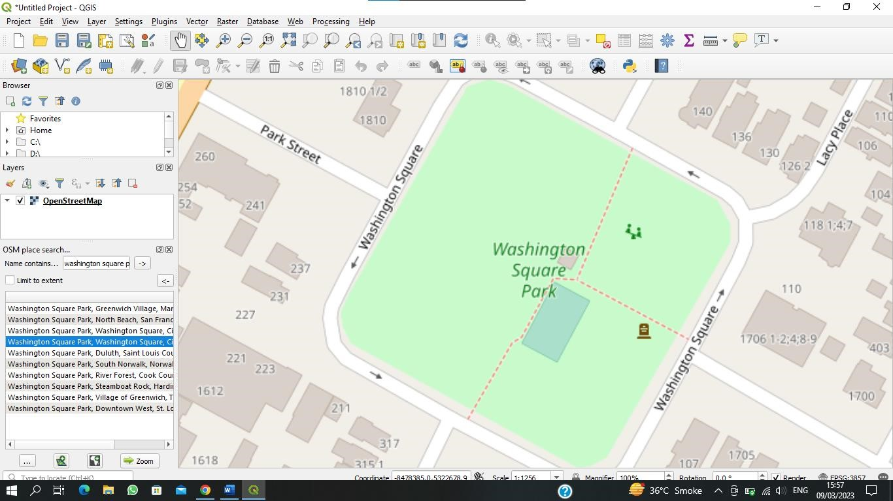

Step 4: Raster-> Georefrencer ->File-> Open Raster -> [NewYork_Washington] Edit ->Add point (Click on image) From

MapCanvas Take a point in the original image ->OK (Take Four points in all the corners) Settings-> Transformation

Settings -> Transformation Type [This plate spline] Resampling method [nearest Neighbour] Target SRS (EPSG:3857-WGS

84/Pseudo-me) Output - raster (gateway_Aenial _Imagery_modified.tif) Load in QGIS when done (select) ok

File-> start georeferencing Close the window ->save-> save Output: we have put the image in the same position

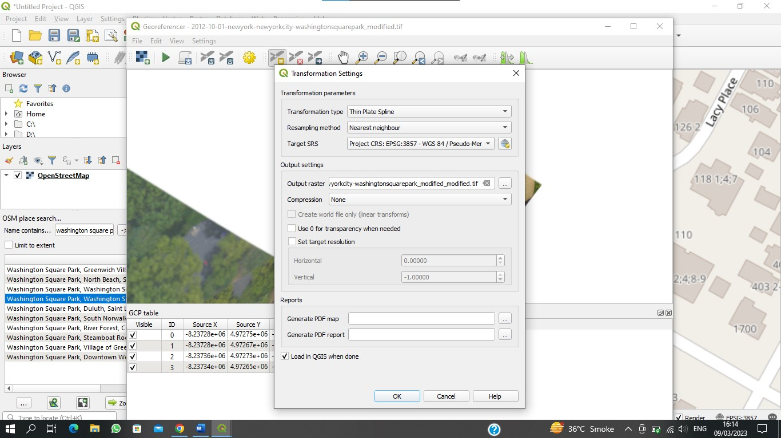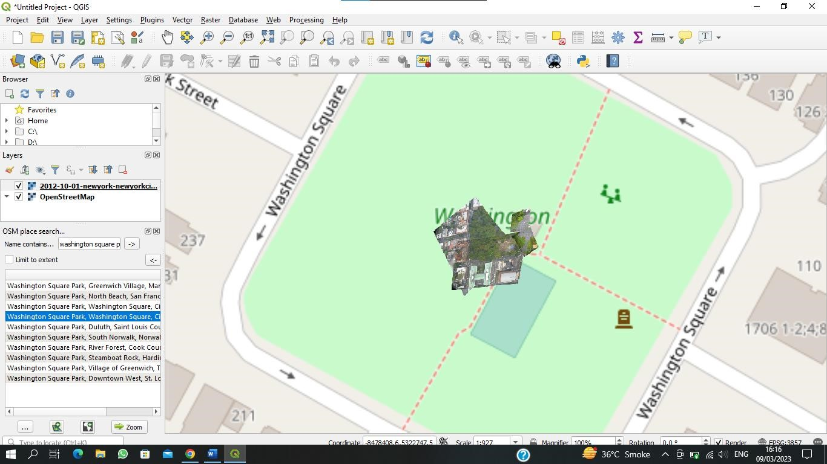

Prac 6c- Digitizing Map data

Step 1: layer ->add layer-> add raster layer-> (Practical_6c -> Christchurch topo50 map.tif)-> add-> ok

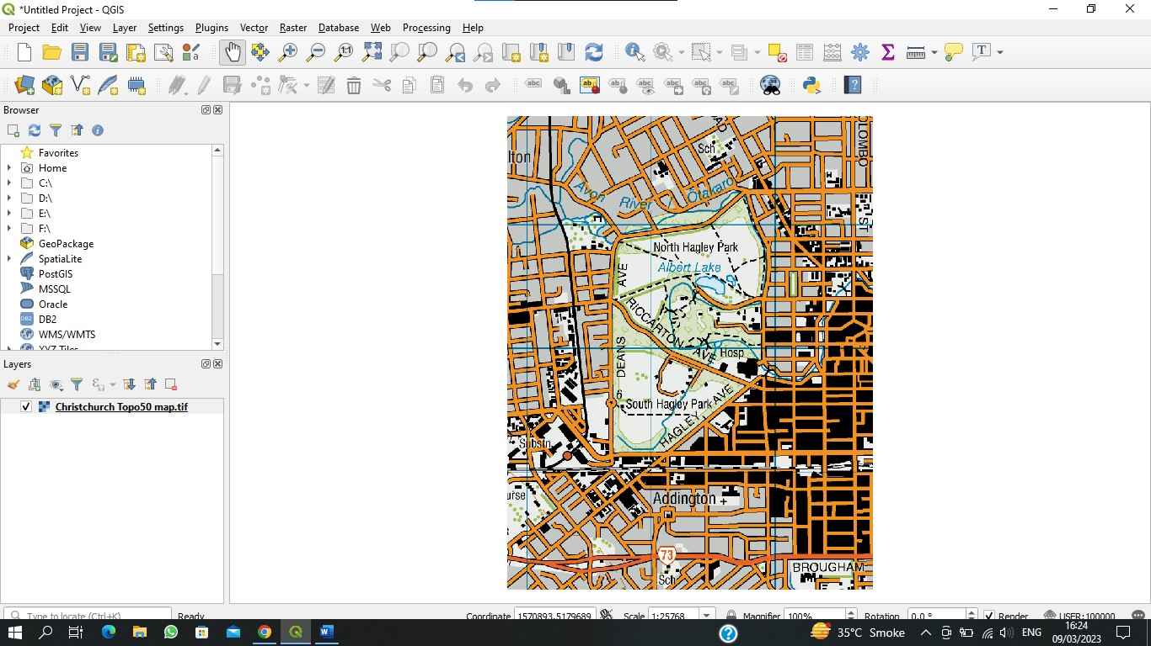

Step 2: right click on the layer->properties->pyramids->select all the resolution from right hand side->Build pyramid ->ok

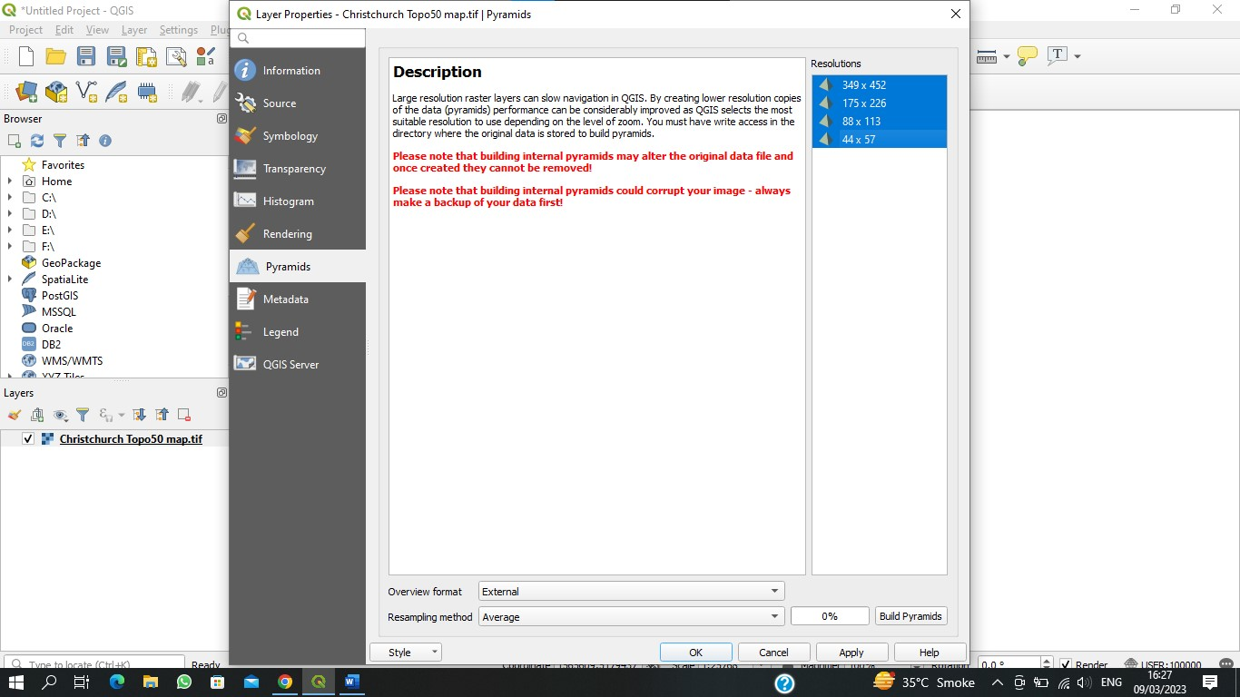

Step 3: settings-> options ->digitizing-> snapping ->deselect the enable snapping by default ->ok

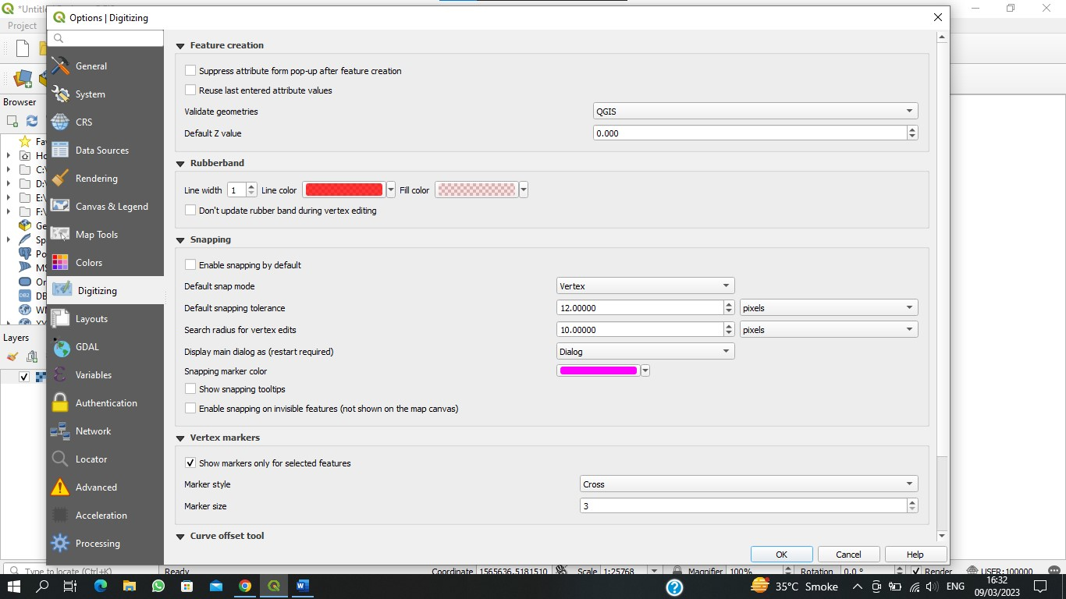

Step 4: layer ->create layer ->new spatialite layer Database (digitization sqlite) layer name (digitized road ) Geometry type (line string) EPSG:4167-NZGD2000 Name(name) text -> Add to field list Name(class) text -> Add to field list Ok

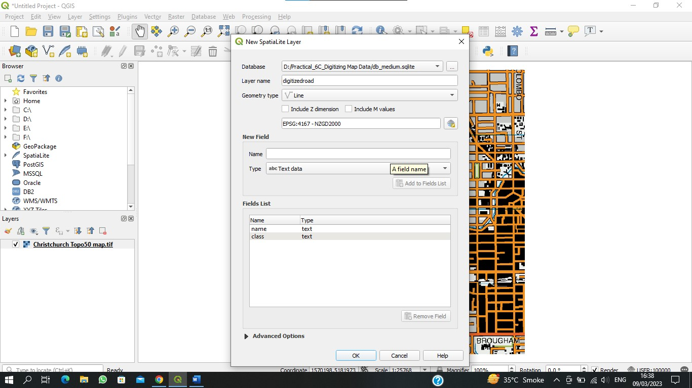

Step 5: toggle(draw the line) Name -sv road. Class- street

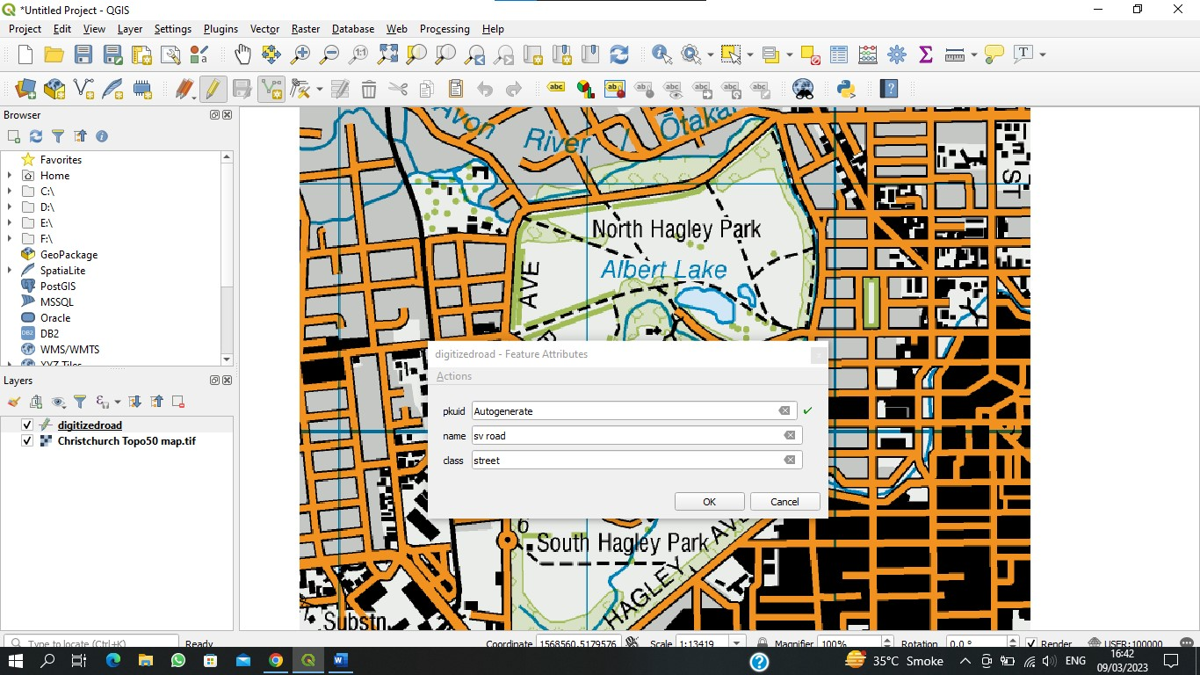

Step 6: right click on digitized road ->properties ->symbology-> colour red (we can clearly see the road)

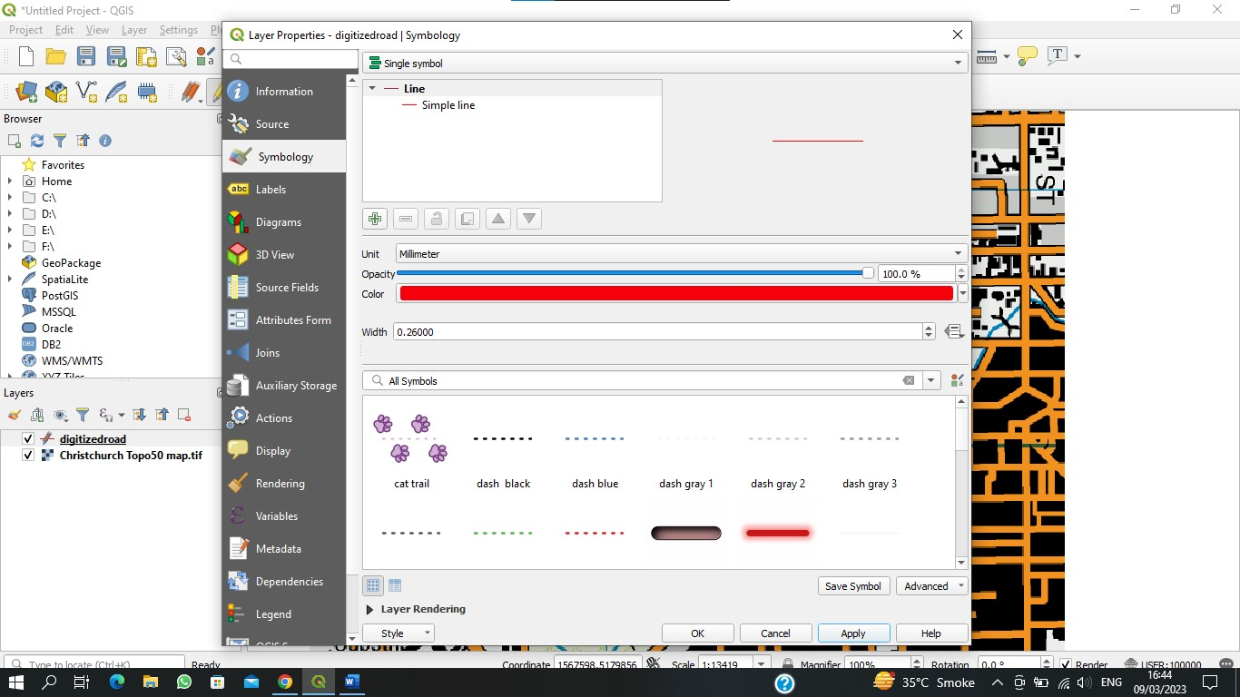

Step 7: layer->create layer-> new spatialite layer -> database (digitization sqlite) (save name) layer name

(digitized_garden) geometry type(polygon) EPSG:4326-WSG 84 Name(name) ->add to field list ->ok

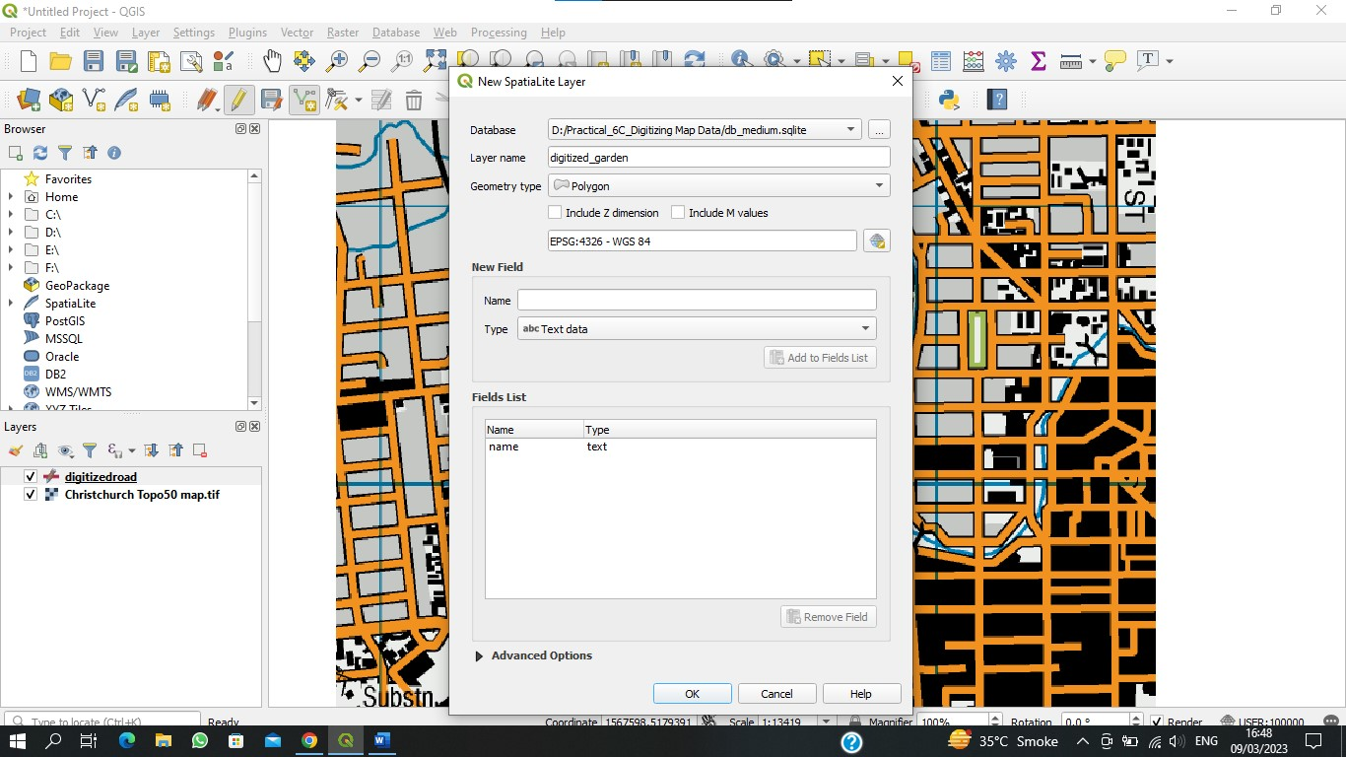

Step 8: toggle-> draw the polygon inside red road Name (garden)-> ok Toggle-> " " Name (garden2)-> ok

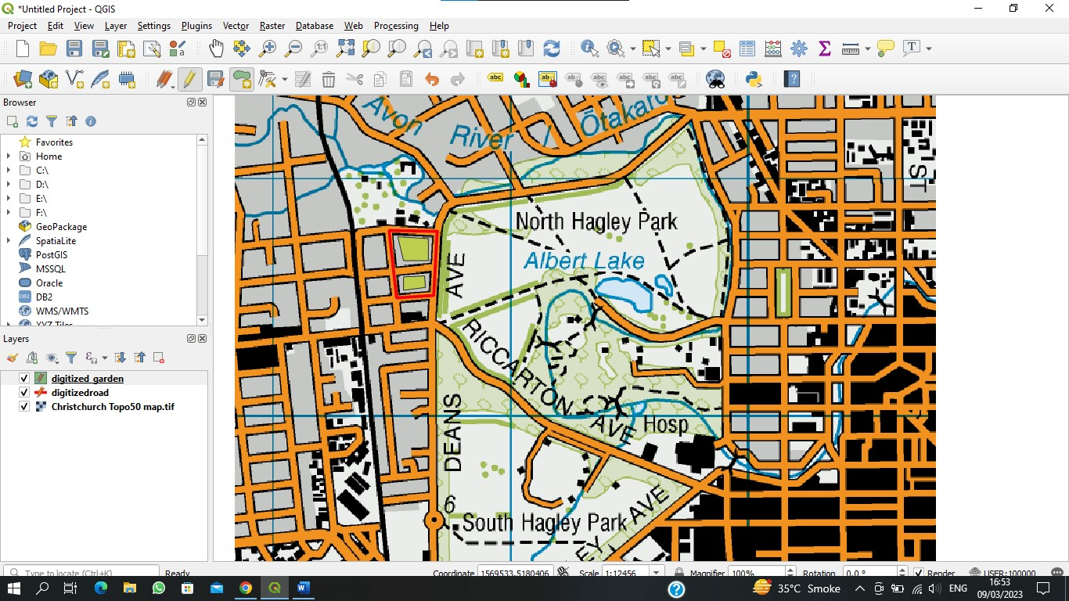

**Practical 7:**

b) Spatial Joins.

C) Points in polygon analysis

d) Performing spatial queries

**b) Spatial Joins.**

**STEP 1**

Layer -> Add Layer -> Add vector Layer → nybb.shp → Add -> ok -> close

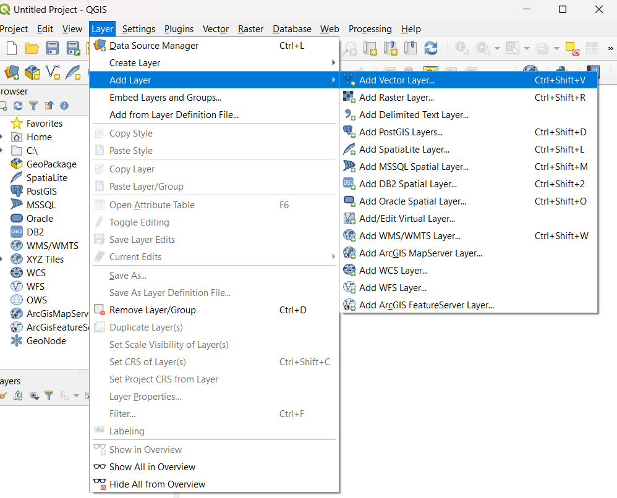

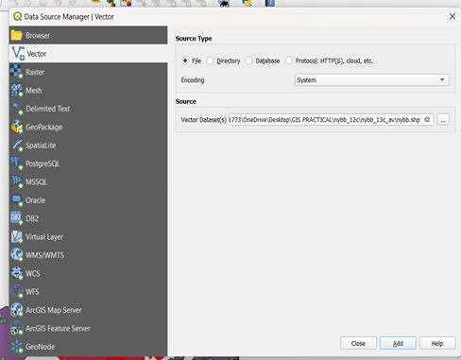

Step II) Layer -> Add Layer->Add vector layer -> OEM-NursingHomes_001.Shp -> Add -> close



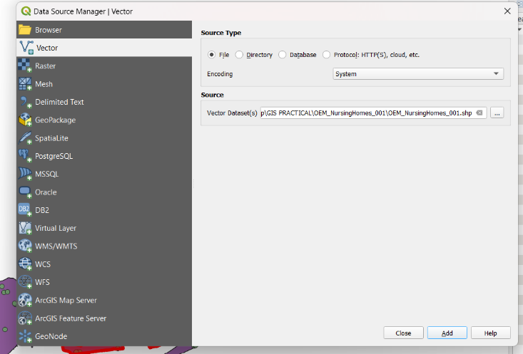

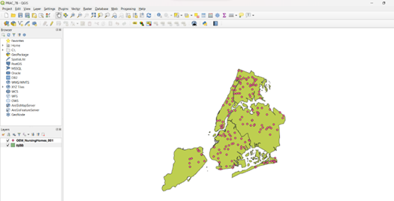

Step III) (check the attributes of both the Layers) Right click on layer -> properties -> Open attribute table (check for other layer)

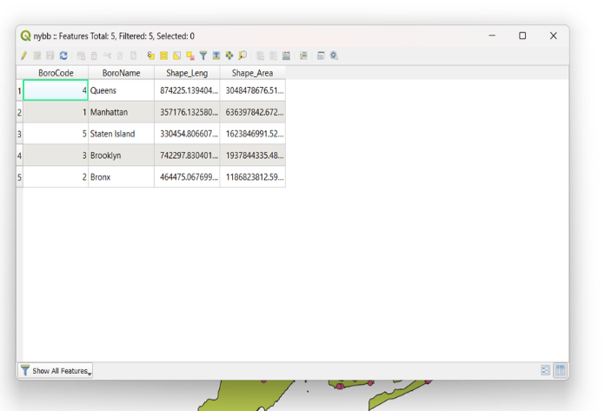

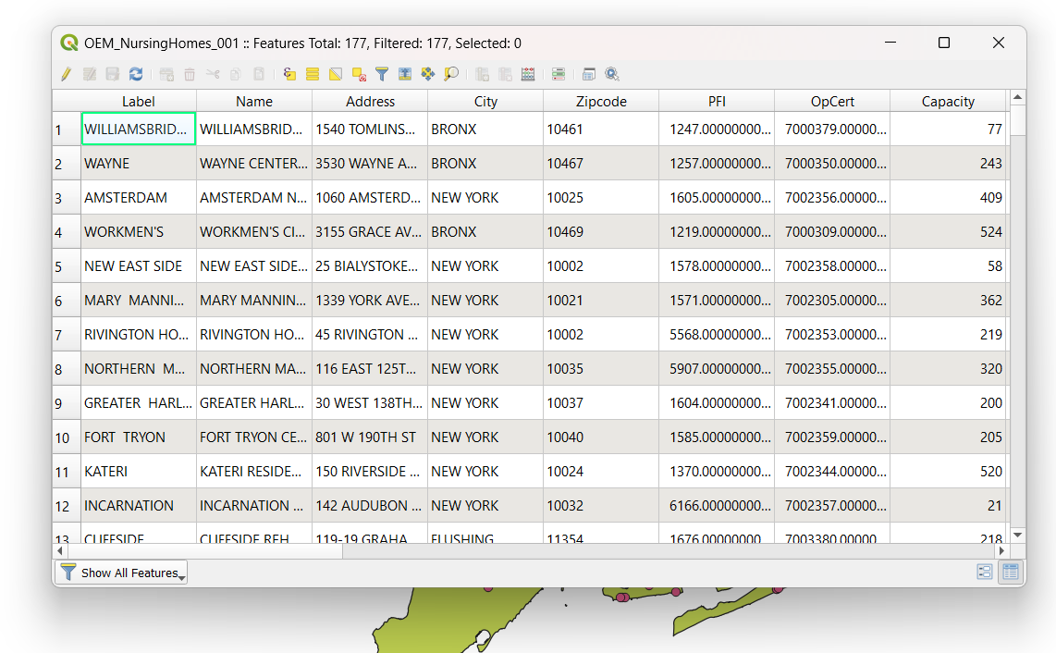

Step IV) Vector -> Data Management Tools → attributes by locations

Base Layer [nybb (EPSG 2263)]

Join Layer [OEM-Nursing Homes_001 [Epsg: 2263]

Geometric predicate

Intersects [Put a tick in-front of this]

Fields to add (click on....)

Parameters: Select all [click on Select all -> ok)

Join type [Table attributes of the first matching feature only (one to one)]

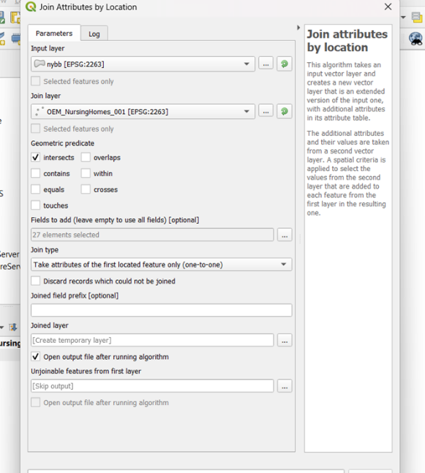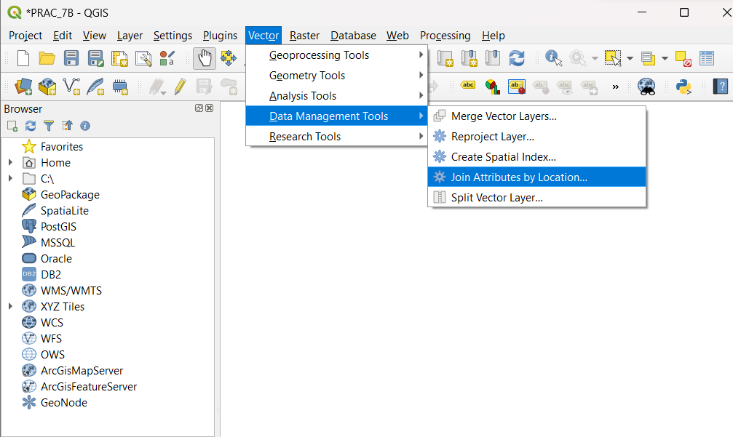Open O/P file after running Algorithm[Put a tick](should be check) → Run → close

Step V) Deselect the nybb & OEM layer from layer panel.

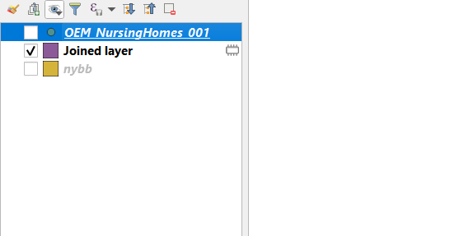

Step VI) click on[i] from menu bar → select OEM layer from layer pannel[put a tick]

Click on map & see the identity result

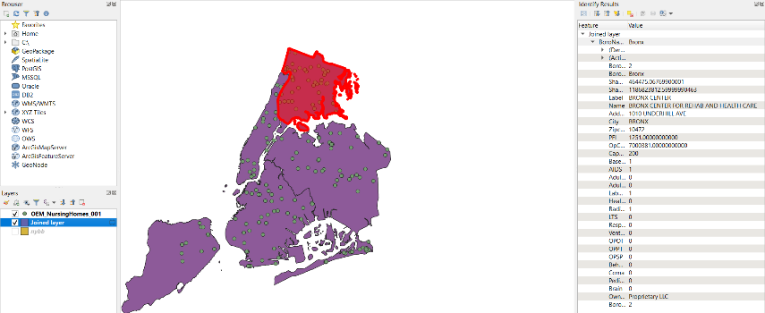

We have added one attribute in polygon to find out earthquake prone areas.

**7c) Points in polygon analysis.**

Step I) Layer → Add Layer → Add Delimited Text Layer

→File Name [Earth Quake Database.txt]

Layer Name [Earth Quake Database] Endcoding [UPF-8 ]

File format Tab ---> Custom delimiters.

Record and Fields options

First record has field names

Detect field types.

Geometry definition.:- x field [longitude]

Y field [Latitude]

Geometry CRS (EPSO:4326. WGS84)

Add → close (we can see the later in layer panel).

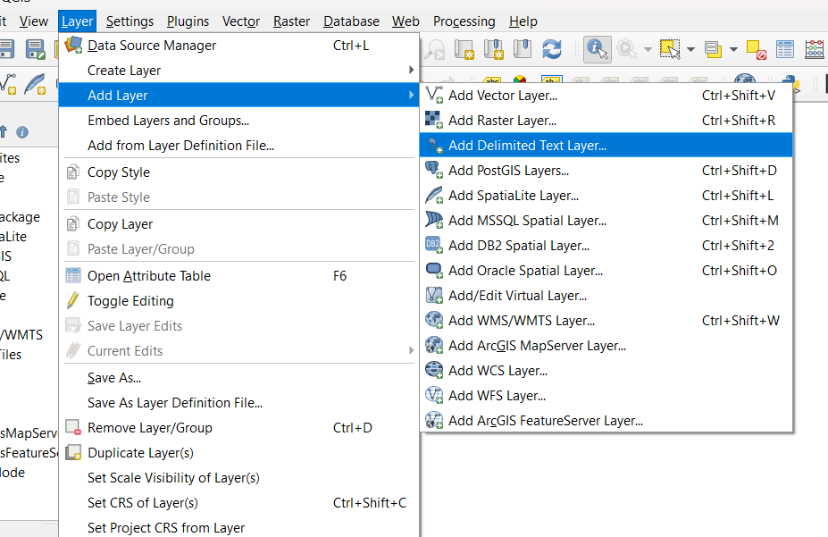

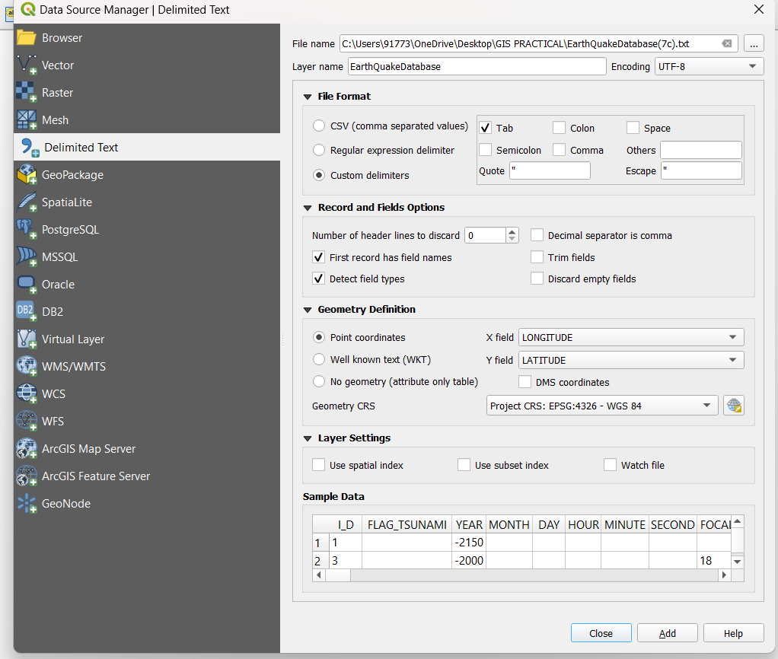

Step II) Layer Add Laver → Add vector layer. [ne-10m_admin_countries. zip- Add → close

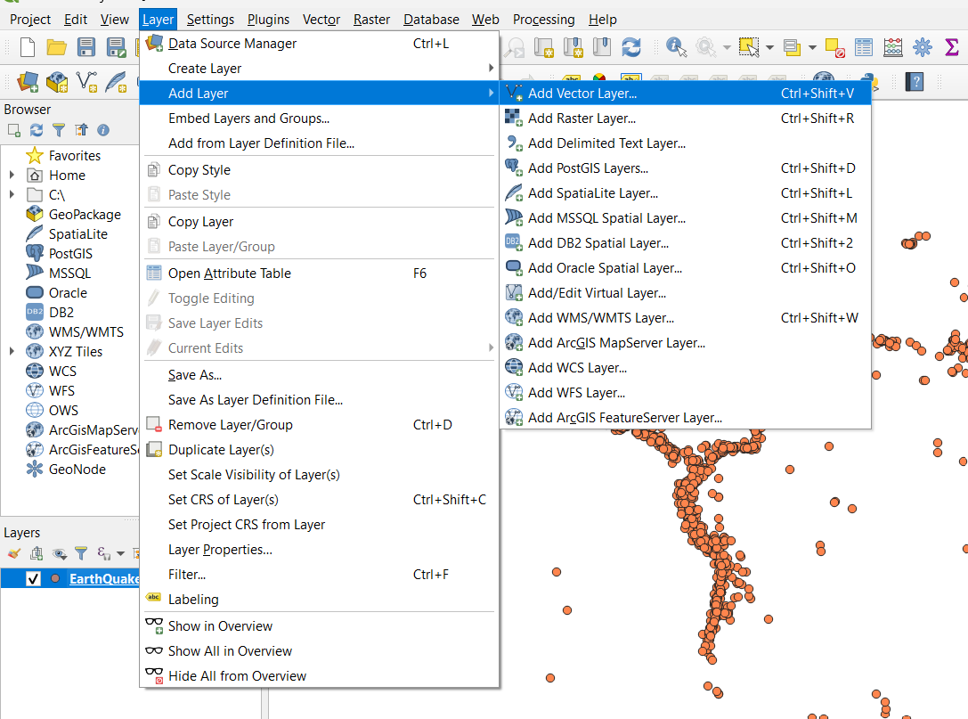

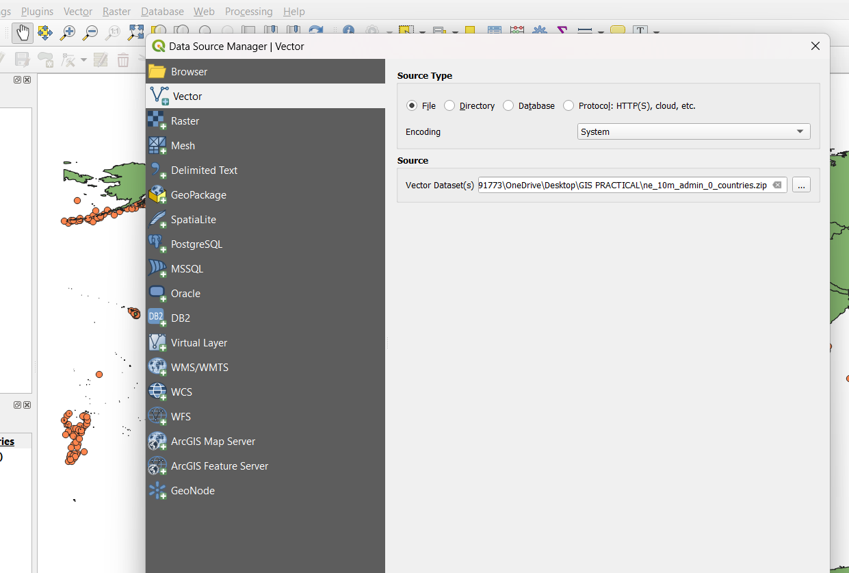

Step III) Vector → Analysis tools → Count points in Polygons

→ Polygon [ne 10m_admin_0_countries]

Points [Earth Quake Database [EPSG: 4326]

count field name Numpoints

Count (earthquake-counts) [...] click on three dots → save to file (Practical_07 → c. [earthquake_count] (check extension should be gpkg)

Open output file after running algorithm → Run (It takes home) -> close

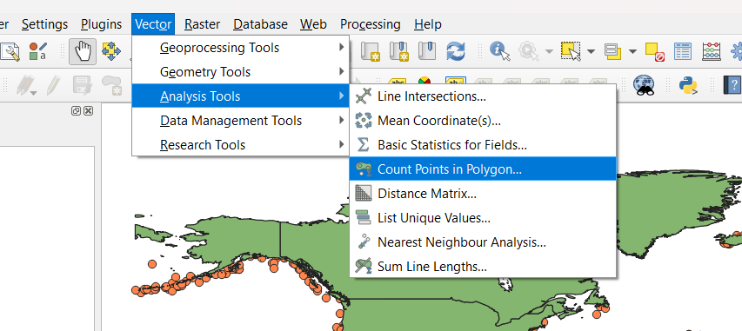

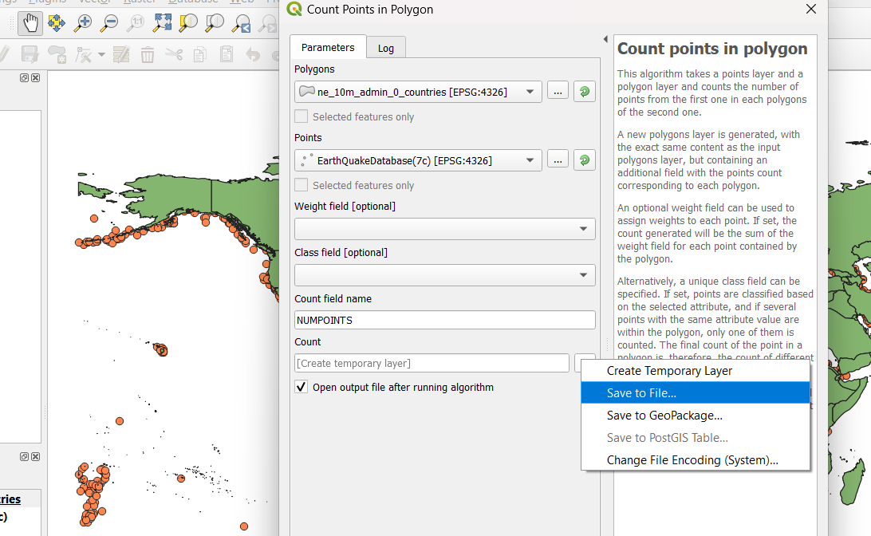

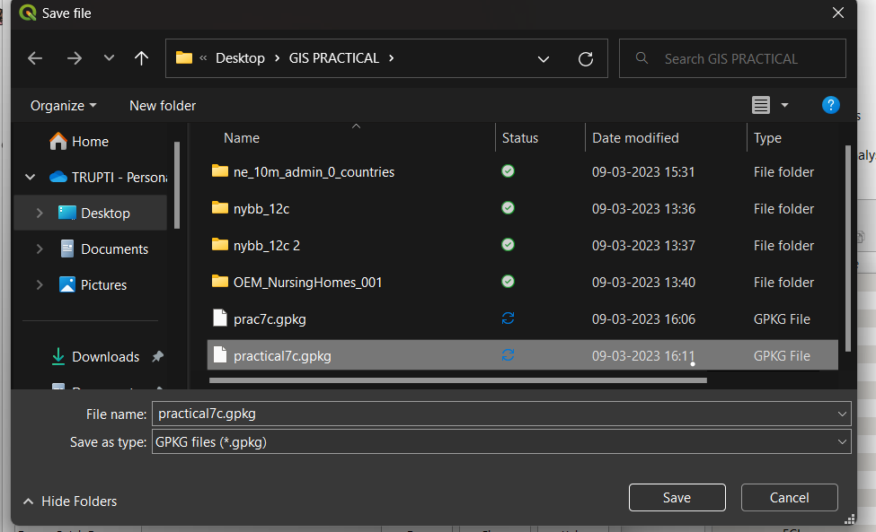

(zoom original image, focus on India).

Step IV) Select select India from map. (we can see the earthquake points in every country & we can see numpoints from Identity results on right hand side)

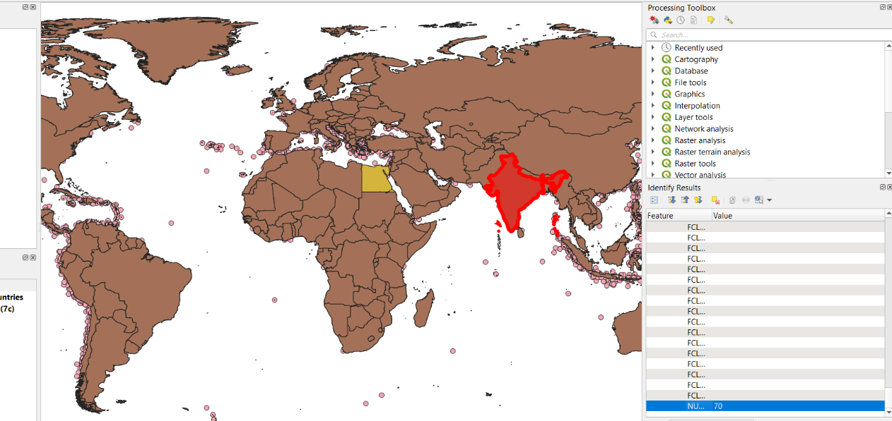

**7D) Performing spatial queries**

Step I) Layer -> Add Layer → Add vector Layer →

ne-l0m-populated-places-simple-shp → Add→ close.



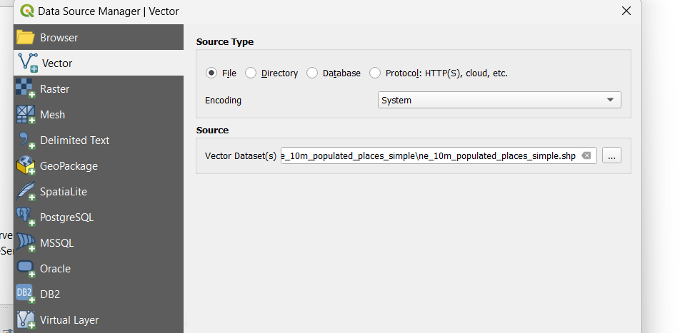

Step II) Layer →Add Layer→ Add vector layer

ne-10m - rivers _lake Centerlines-shp→ Add → close



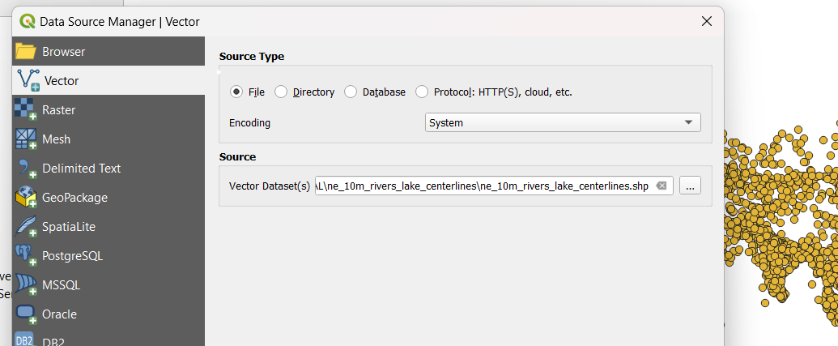

Step III) Right click on ne_10m_rivers_lake-centerlines.shp → Properties → symbology → color (topo hydrology)

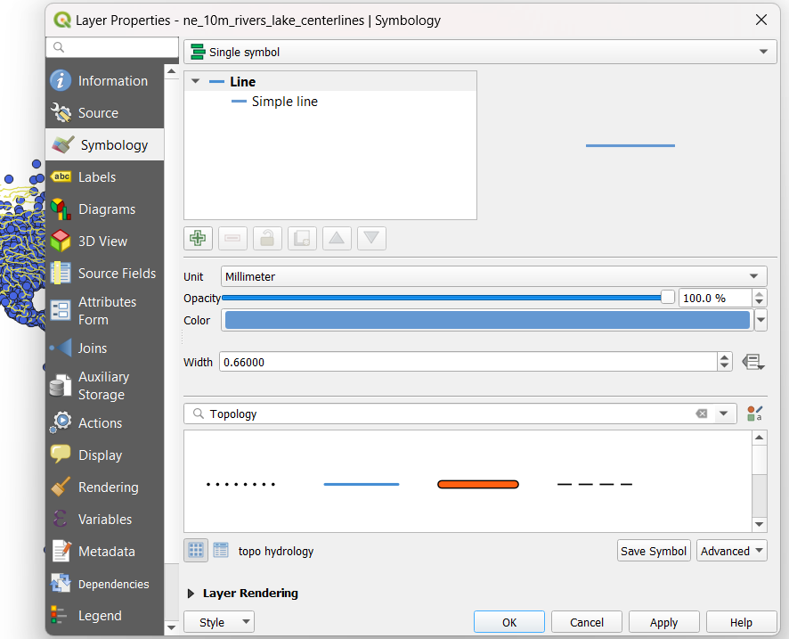

Step IV) We need to change its CRS (Coordinate System) Project→ Properties→ CRS → Search for 54022. [work Azimuthal equidistant] ESRI £4032) →ok. ( we can see 3D Globe map. We have Converted 2D into 3D format)

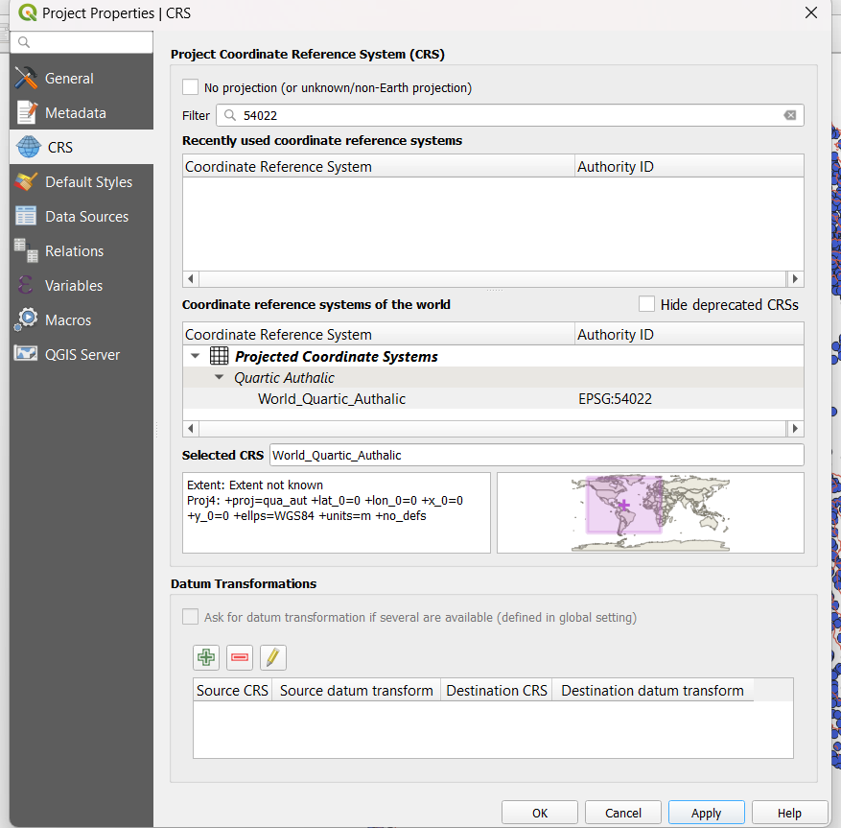

Step V)

Vector→ Geo processing tools → Buffer input layer [ne_10m_rivers_lake_centerlines] Distance [0.020000 (we are concentrating on rivers which are in 2km dist)

Segments[5]

End cap style [Round]

Join style [Round]

Milter Limit [2.000000]

Open output file after running algorithm (we are not saving this file we are creating temporary file) →run-🡪 close

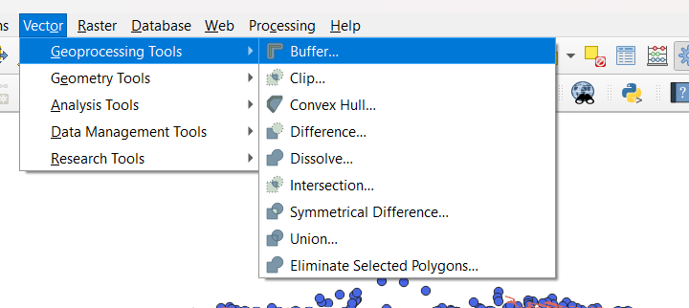

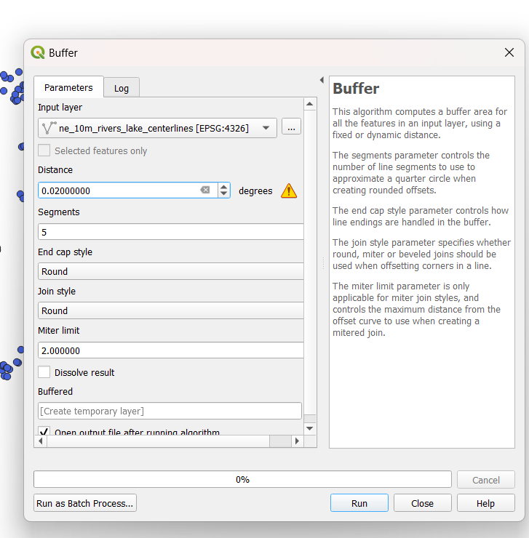

Step VI) Rivers are not clearly seen so we will Chang the color of **populated places**. Right click on ne_l0m_Populated_places_simple. →properties → symbology → color [Brown] → Apply → Ok

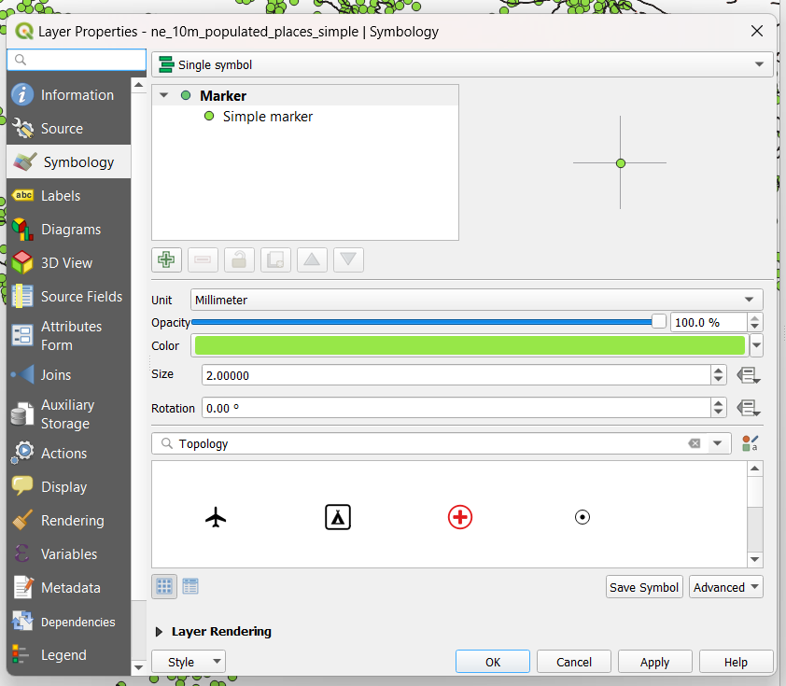

Step VII) Vector → Research tools → Select by location. → Select features from [buffered [EPSG: 4326] where the features Geometric predicate)

[Intersect]

By comparing to the features from.

[ne_l0m_populated-places-simple]

Modify current selection by [creating new selecting]

Run → close (we can see the highlighted rivers. These rivers are with different colour). These rivers are near to show high populated areas.

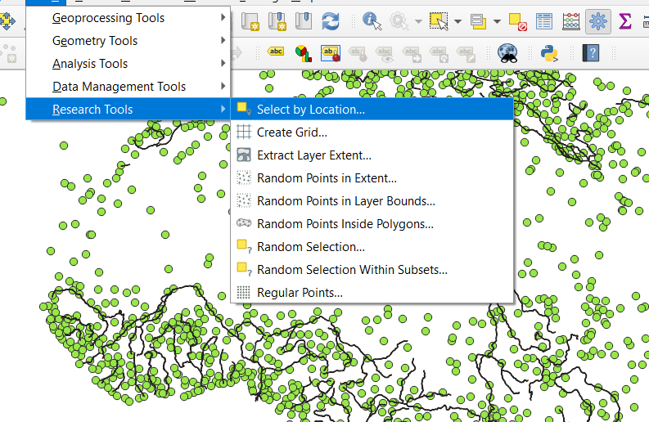

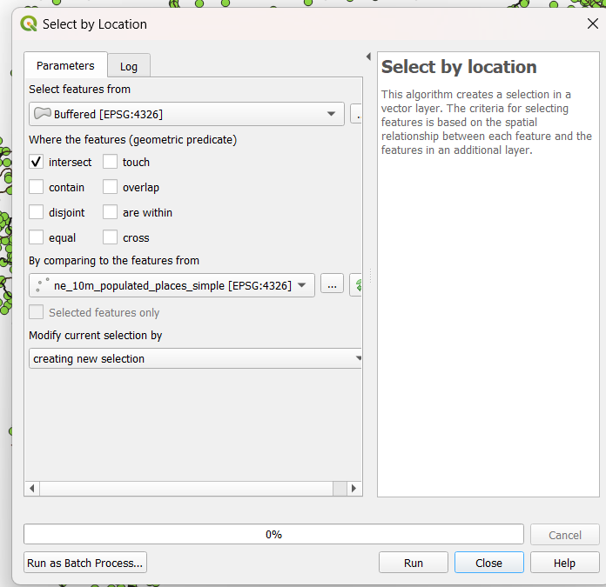

Step VIII) Right click on ne_10m _lake_river_center

→ properties → Labels

Single labels →Label with [name] → Apply→ok.

( we have highlighted those rivers which are near to the populated areas in 2 kms.)

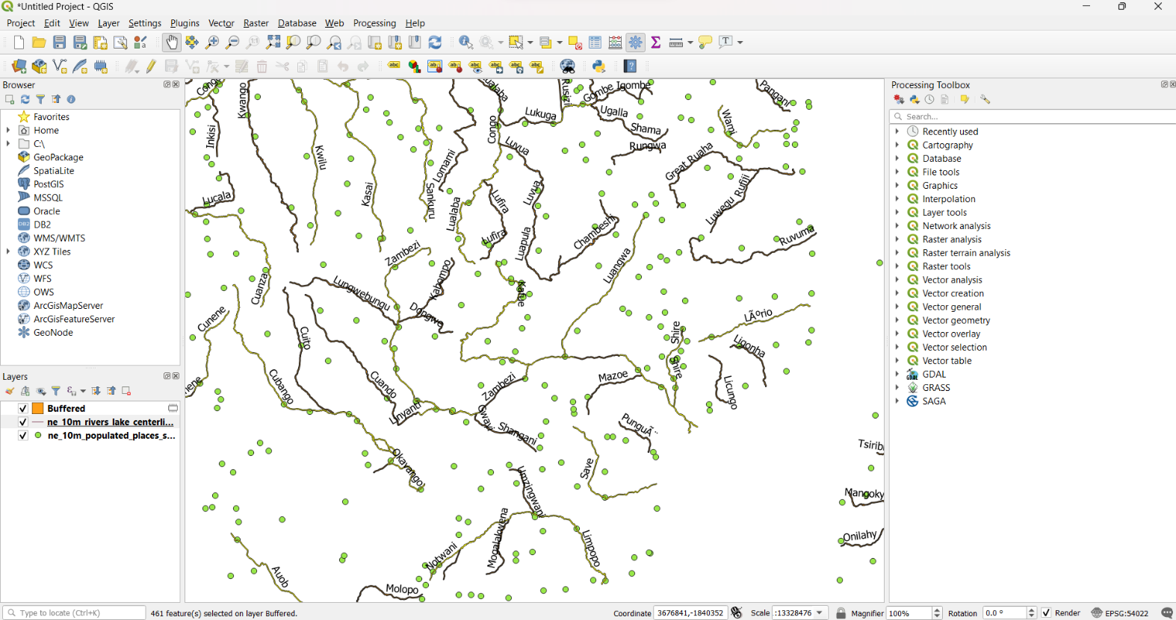

**Practical 8**

Prac 8 a)**Nearest Neighbour Analysis**

GIS is very useful in analysing Spatial relationship such analyse is finding

between features. One out which feature are closest to a given feature. COGGS has a too called Distance Matrix which helps with such analysis. In this practical. Our goal is to find out the nearest point from. For each of the points. the populated places layer. In the earthquake layer. Tool Distance Metrix to toolbox that processing will explore nearest hub from they can not only find the distance to the closest Belt jour it hit with a live to it results feature for visualizing the

Step I: Layer Add Layer -> Add vector layer (ne-10m-

populated places simple. Shp)

→ Add close

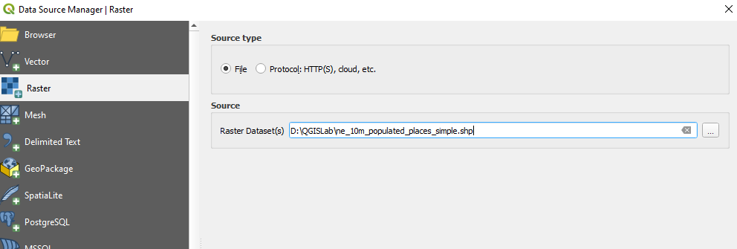

Step II: Layer Add Layer Add Delimited text layer 11

File name Earthquakes_2011_11_25_14-31.tsv

Layer have earthquakes 2021-

Encoding UTF-8

File format Custom delimiters tab

Point Co-ordinates

Longitude(x) Latitude(y)

CRS: EPSG:4226 - WGS-84

Add → close

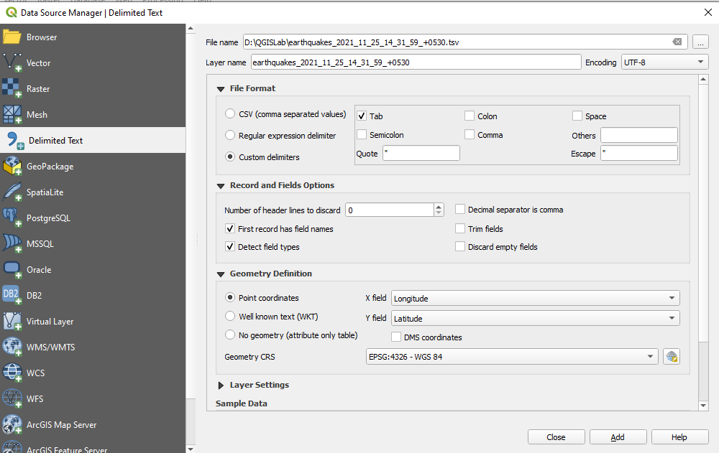

StepIII: We can change the colour using Symbology

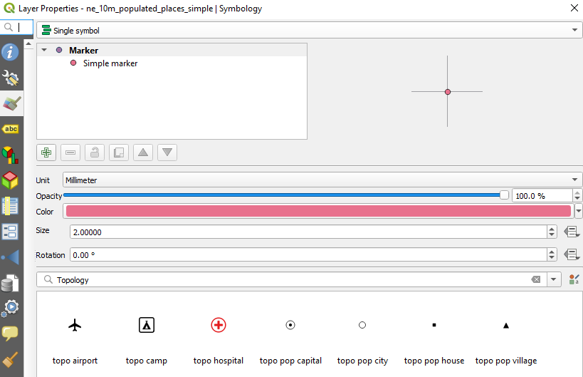

StepIV: Right click on earthquakes_2021 -> Open attribute table.(we can see multiple hill values 8. Longitude & latitude values are mussing 2 we have to remove null value.

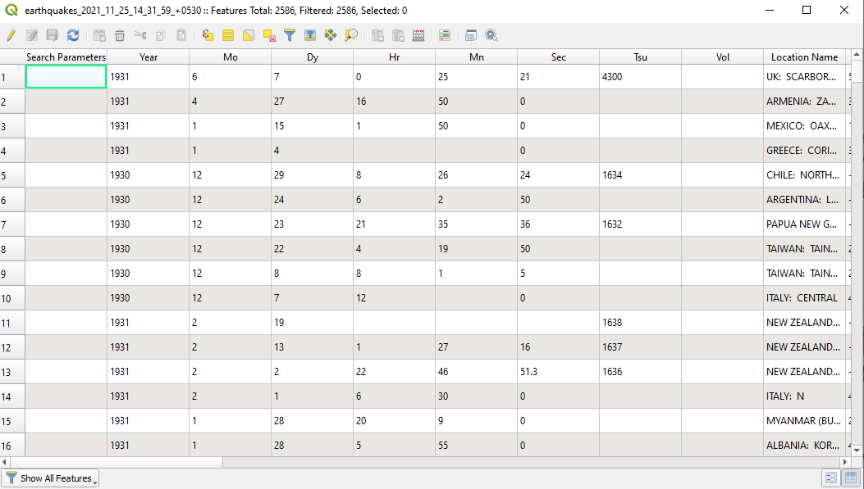

StepV: Processing ->Toolbox -> Vector ->Geometry ->Remove

Null geometrics.

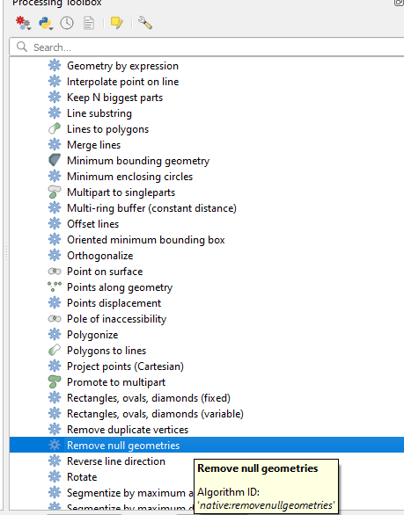

Input layer [earthquakes 20 Also remove empty geometries]. (Check this option)

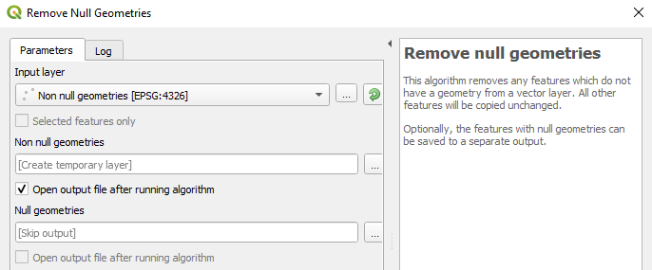

Open output file after running algorithm (check this option)

→ Run close,

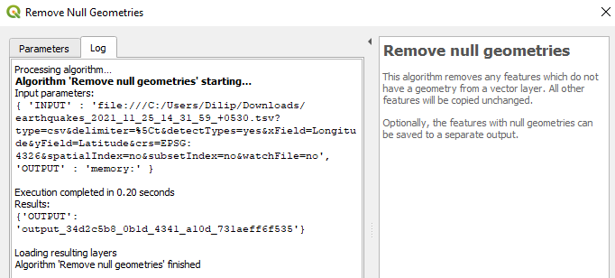

Step VI: Deselect earthquake 2021 from Layer panel

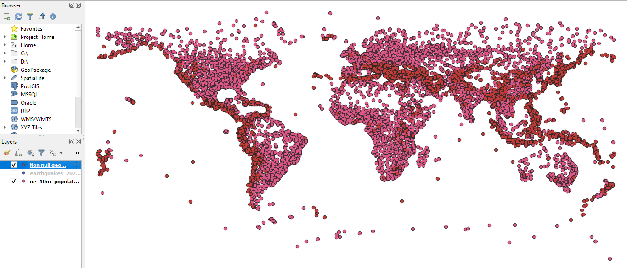

StepVII: Right click on Not null geometry &- properties ->

>Symbology [Any Colour]

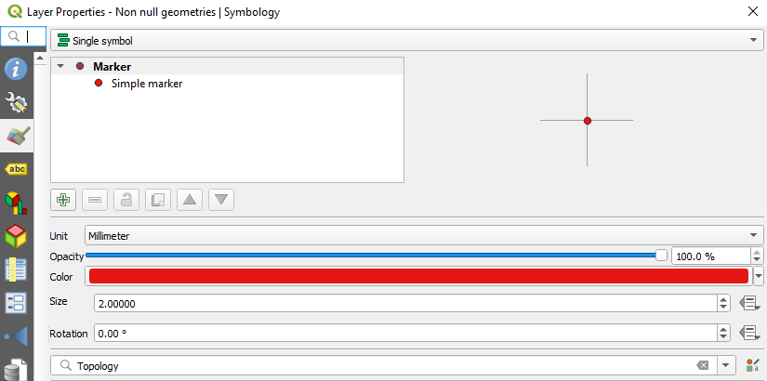

StepVIII: Right click on not well geometries Open attribute table

(Check for Latitude & Longitude columns are filled with values)

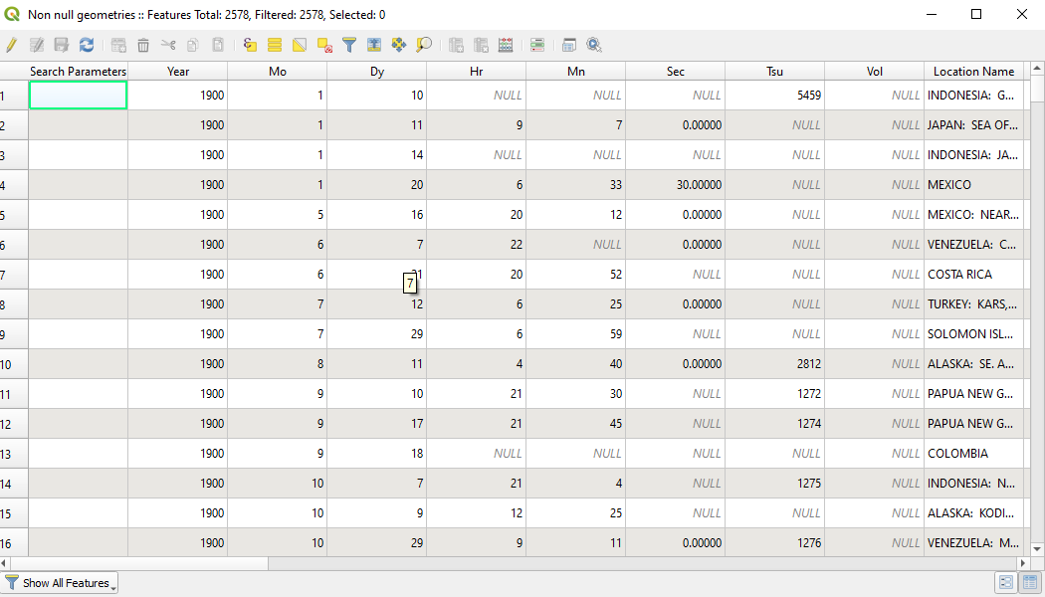

StepIX: Processing toolbox → Vector analysis -> Distance to nearest hub (line to hub).

Source points layer. not null geometries.

Destination hubs layer. The low-populate

Hub layer name attribute [ABC name]

Measurement unit [Kilometer]

Hub distance [Save to file]

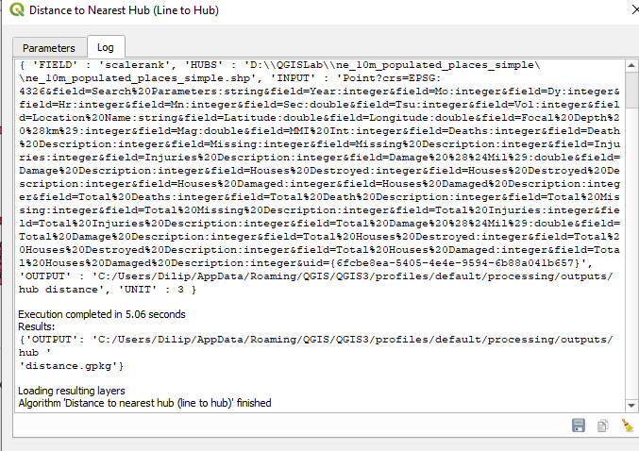

(->earthquake city, gpkg open output file after running) -> Run -> Close

(Red dots -> earthquake

Green clots -> populated place

Lines -> connecting Earthquake & populated place)

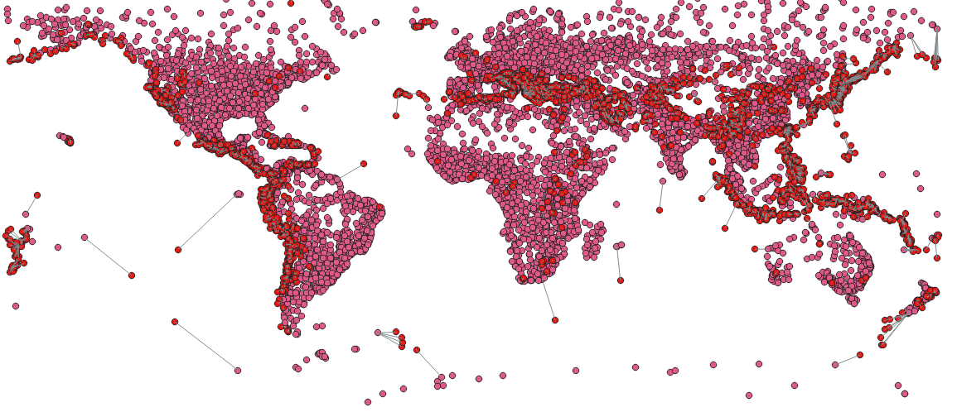

Step X: Right click on HUB -CITY -> Open attribute table

(check for Hub Name, Hub Distance we have added these two extra columns)

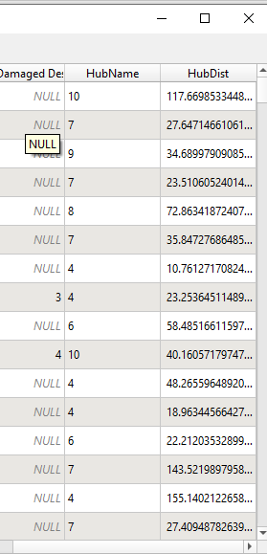

Prac 8B: Sampling Raster Data using Points & polygons.

Step I: Layer → Add Layer - Add Raster layer →us.

tmax_nohads-II-20140525-float.tif

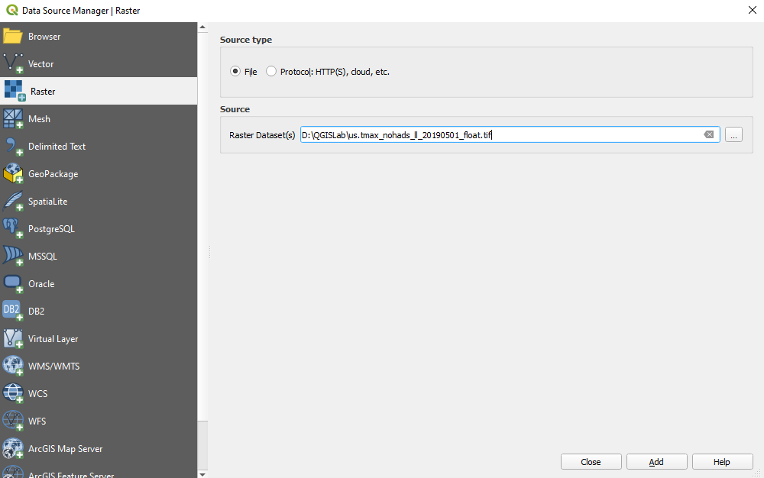

Step II: Click on [i] from menu bar

check coordinates.

If keeps charging while moving the cursor

StepIII: Layer - Add Layer - Add Delimited text Layer

Layer name /2018-Gaz_ua_national)

Encoding [-UTF-8

Custom delimiters [v] Tab

Point coordinates x field INTPTLAT

y field INTPTLONG

CRS :-EPSG 4326 WGS 84

Add -> Close

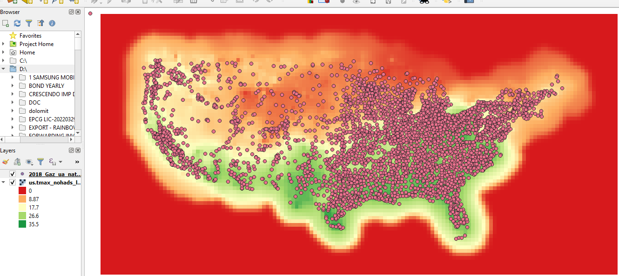

StepIV: Processing→ tool box → Raster Analyse -> Sample raster

values.

Input layer [2018 Gaz-ua-national [EPSG:4326]

Raster layer [us-tmax-honds-II-20140525-float

Output column.prefix tmax_[v] output file after running

algorithm.

Run->Close

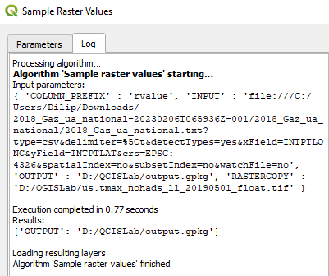

StepV: select [i] from menubr -> click on window

(we can see tmax values right side of identify result)

Step Vi: Right click on Sampled -> Open attribute table

(We can see tmax column which we added)

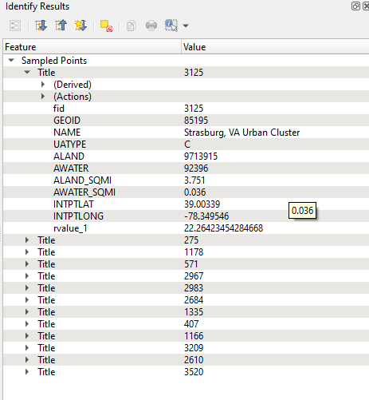

Remove Sample & 2013_Gz layer from layer panel so that we can do the second part.

Layer -> Add layer -> Add vector layer ->tl_2018_us_country. shp -> Add-> ok-> Clos

Processing -> toolbox -> zonal statistics->Input layer: - FET-2018-us-county]

Raster Layer: - us_tmax-hohads_11_20__ [EPSG:4326]

Raster band: -Band 1 (Gray)

Output column prefix Imax_.

Statistics to calculate [i] click on it

Select only mean -> ok

Open output file after running algorithm→ fun close.

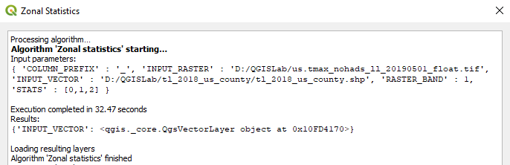

StepII: Select [i] from menu bar click on window & check. Open

attribute table & check Column tmax in.

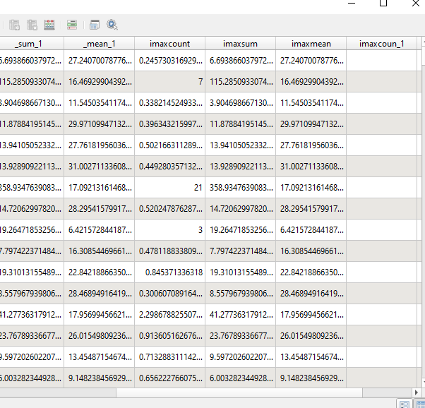

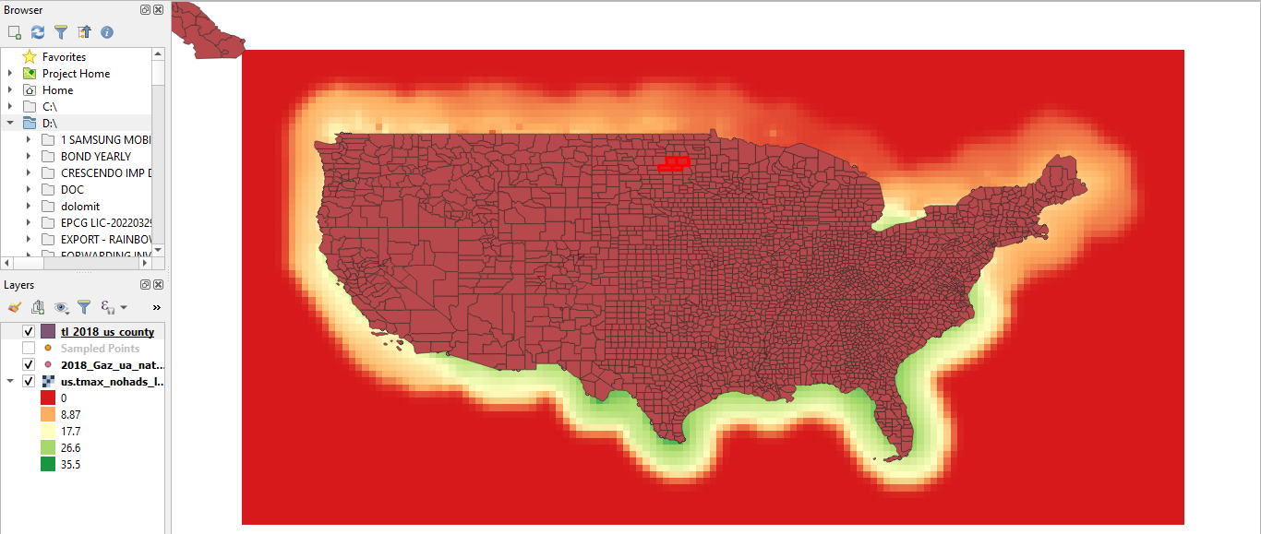

﻿

Prac 8C: Interpolating Point Data

Interpolation is a commonly used GIS technique to create a continuous. surface from discrete points. In QGIS, Interpolation is achieved using the built in Interpolation tools from the processing toolbox.

In this practical we will take field depth measurements for Lake Arlington in Texas. & create an elevation relief map & contours from these measurements

**Step I:**

Layer → Add Layer → Add Vector Layer → Arlington_Soundings _2007_Stpl 83.shp → Add → close.

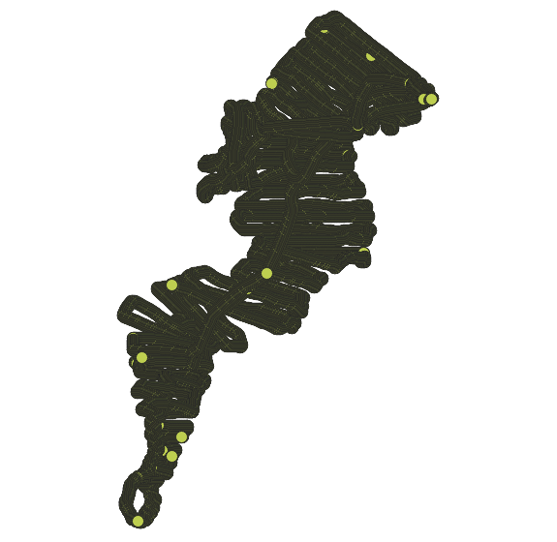

**Step II:**

Layer → Add Layer → Add Vector Layer → Boundary2004_550_stp183.shp → Add → Close

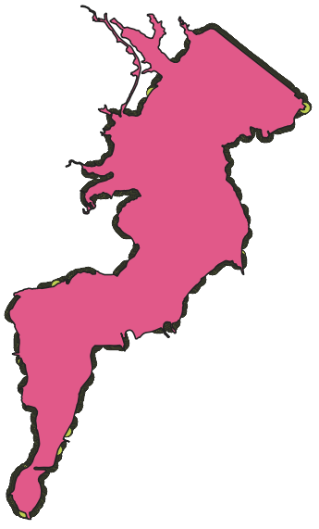

**Step III:**

Disselect Boundary.shp layer from layer panel

**Step IV:**

Zoom the window & take the dotted lines

**Step V:**

Click on identify feature & click on window one dotted.

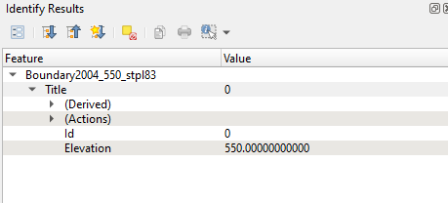

**Step VI:**

Zoom out click on ✋(hand emoji) will come to original image. & select the boundary.shp

**Step VII:**

Add layer → Add vector layer → Islands_2004_550_stp183.shp

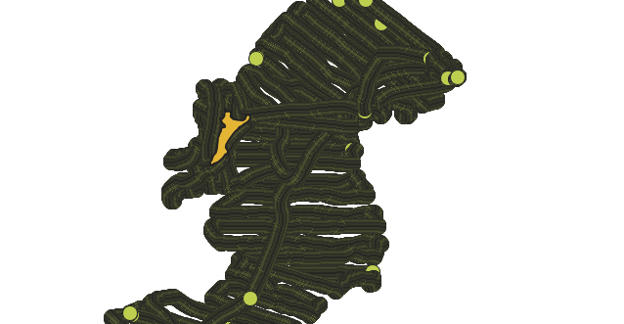

Processing → ToolBox → Interpolation -> TIN interpolation

Vector layer: Arlington_Soundings_2007_stp183

Interpolation attribute: Elevation

Click on [+] → set Type :- [Points]

Vector layer: Islands_2004_550_stp183

Interpolation attribute: Elevation

Click on [+] → set Type:- [Break lines]

Interpolation method [Linear]

Extent[…] →  Calculate from layer → Boundary 2004_550_stp183

Output Raster Data

Rows [4352]              Columns[2533]

Pixel Size X [5]          Pixel Size Y[5]

Interpolated […] Save to file

File name [elevation_tin.tif]→ Save

Tic the option:- Open output file after running algorithm → Run → Close

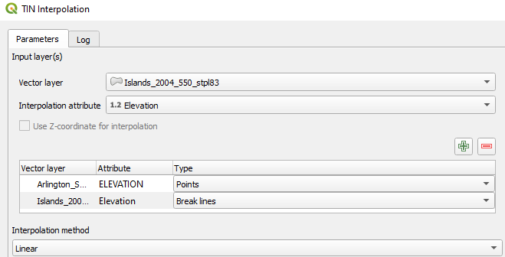

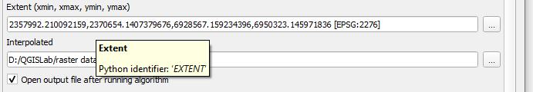

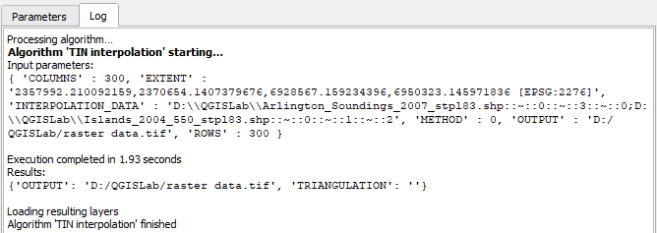

**Step VIII:**

Disselect all layer. Only keep elevation_tin

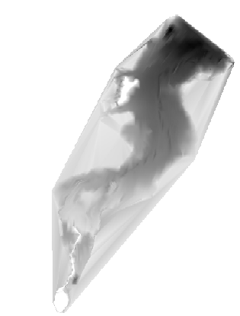

Processing → toolbox → GDAL → Raster extraction → clip raster by mask layer

Input layer                     [Interpolated EPSG:2276]

Mask Layer                   [Boundary 2004_550_stp183(EPSG:2276)]

Clipped […] save to file

       elevation_tin_clipped.tif

Tic the option:- Open  output file after running algorithm → Run → close

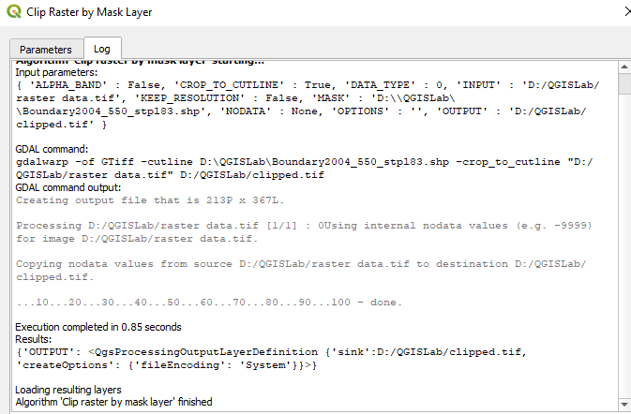

**Step IX:**

Disselect the elevation_tin

Only keep elevation_tin_clipped

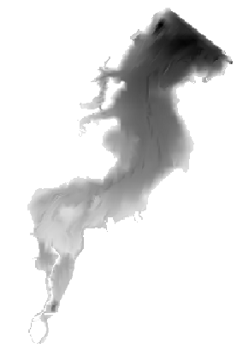

**Step X:**

Right click on elevation_tin_clipped → Properties → Symbology

Render type :-  Singleband pseudocolor

Band Min[501.84]            Max[550]

Interpolation[Linear]                     Label unit static: blank

Color Ramp [Invert color Ramp]

Label precision  4

Click on classify → OK

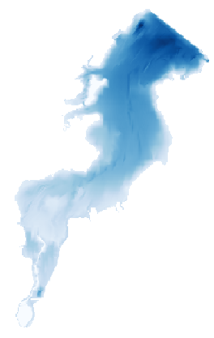

**Step XI:**

Processing → tool → GDAl -> Raster extraction → contour

Input layer: [clipped (mask) [EPSG:2276]

Band number: [Band 1 (Gray)]

Interval between contour_lines:   [5,000,000]

Attribute name: [ELEV]

Offset from zero 0.000000

Contours[…] save to file →Contour.gpkg

Tic the option :- Open output file  ->Run → Close

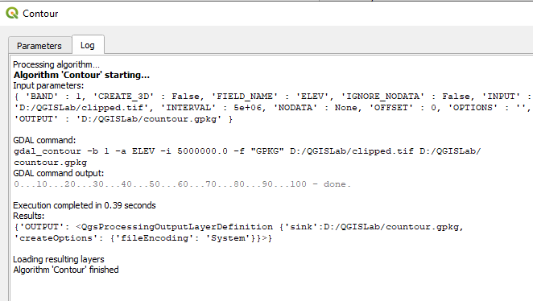

**Step XII:**

Right click on contour → properties -> labels → choose single labels

Label with :- value [ELEV]

Select Placement

Mode: [Curved]

Distance: 0.0000

               Millimeter

Repeat :- No repeat

               Millimeter

Apply → OK

**Step XIII:**

Select contour & elevation_tin_clipped from layer panel.

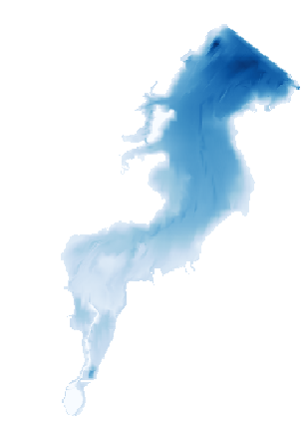

PRACTICAL 9

Prac 9- Advance GIS Operations 2: Batch Processing using Processing Framework Automating Complex Workflows using Processing Modeler Automating Map Creation with Print Composer Atlas

A) Batch Processing using Processing Framework

Step 1:- Go to Layer ‣ Add Vector Layer. Add “ne_10m_admin_0_countries.shp”

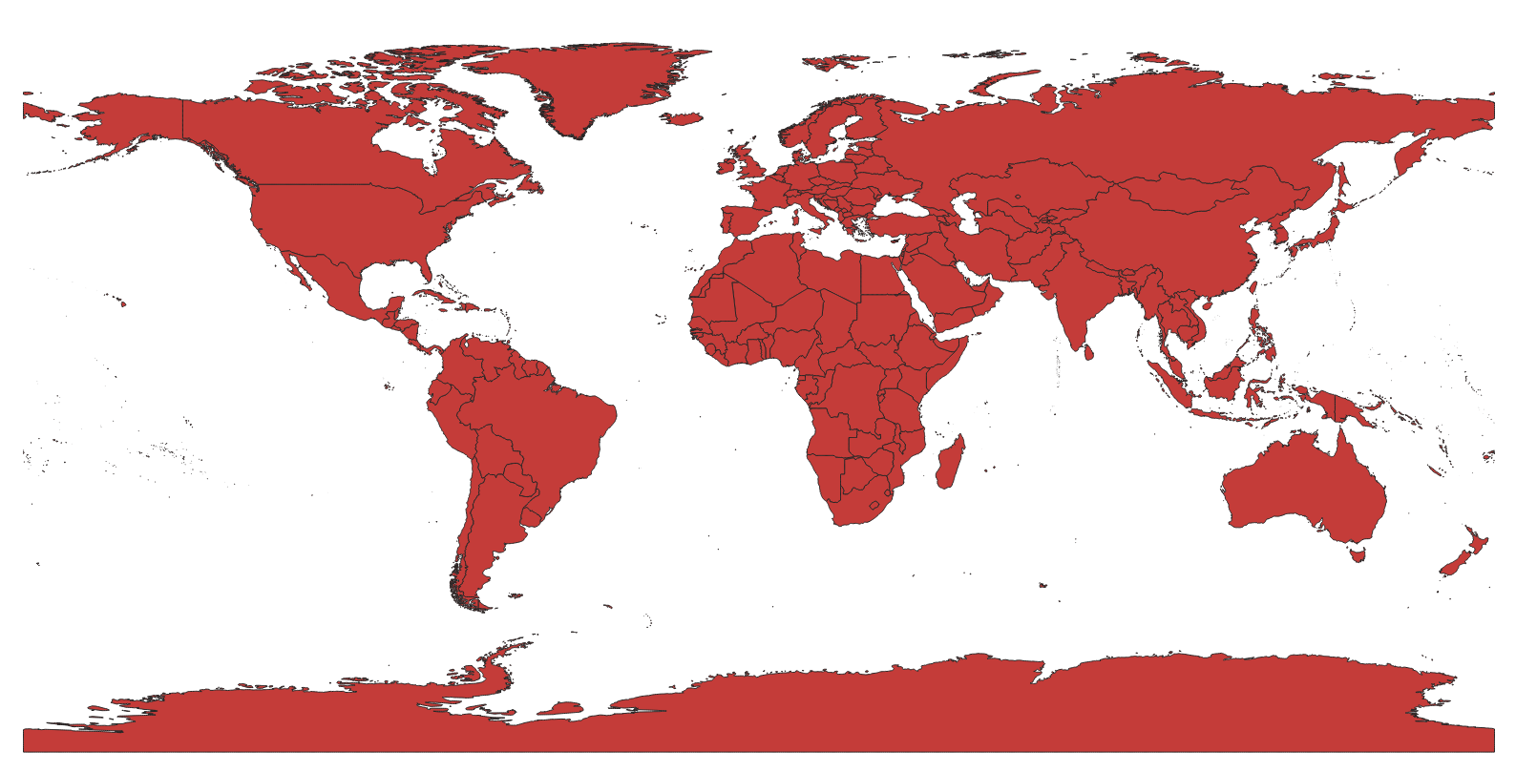

Step 2:- Open the Dissolve tool from Vector ‣ Geoprocessing Tools ‣ Dissolve.

Select ne_10m_admin_0_countries as the Input vector layer. The Dissolve field would be CONTINENT. Name the output file as continents.shp and check the box next to Add result to convas.

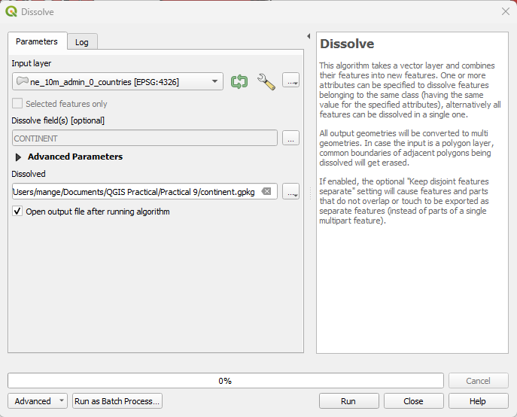

Step 3:- The dissolve processing may take a while. Once the process finishes, you will see the new continent layer added to QGIS. Use the Select Single Feature tool from the toolbar and click on Africa to select the polygon representing the continent.

B) Automating Complex Workflows using Processing Modeler

Step 1:- Launch QGIS and go to Processing ‣ Graphical Modeler....

Step 2:- The Processing modeler dialog contains a left-hand panel and a main canvas. Select the Inputs tab in the left-hand panel and drag the + Raster layer to the canvas.

Step 3:- A Parameter definition dialog will pop-up. Enter Input as the Parameter name and mark Yes to Required. Click OK.

Step 4:- You will see a box with the name Input appear in the canvas. This represents the landcover raster that we will use as input. Next step is to apply a Majority filter algorithm. Switch to the Algorithm tab from the bottom-left corner. Search for the algorithm and you will find it listed under SAGA provider. Drag it to the canvas.

Step 5:- A configuration dialog for Majority Filter will be presented. Leave the values to their default and click OK.

Step 6:- You will note that there is now a new box named Majority Filter in the canvas and it is connected to the Input box. This is because the Majority Filter algorithm uses the Input raster as its input. The next step in our workflow is to convert the output of majority filter to vector. Find the Polygonize (raster to vector) algorithm and drag it to the canvas.

Step 7:- Select ‘Filtered Grid’ from algorithm ‘Majority Filter’ as the value for Input layer. Click OK.

Step 8:- The final step in the workflow is to query for a class value and create a new layer from the matching features. Search for the Extract by attribute algorithm and drag it the canvas.

Step 9:- Select ‘Vectorized’ from algorithm ‘Polygonize (raster to vector) as the Input Layer. We want to extract the pixels that represent Croplands. The corresponding pixel value for this class will be 12. (see Code Values). Enter DN as the Selection attribute and 12as the value. As the output of this operation will be the final result, we need to name the output. Enter vectorized class as the Output.

Step 10:- Enter the model name as vectorize and group name as raster. Click the save button. Name the model vectorize and click Save.

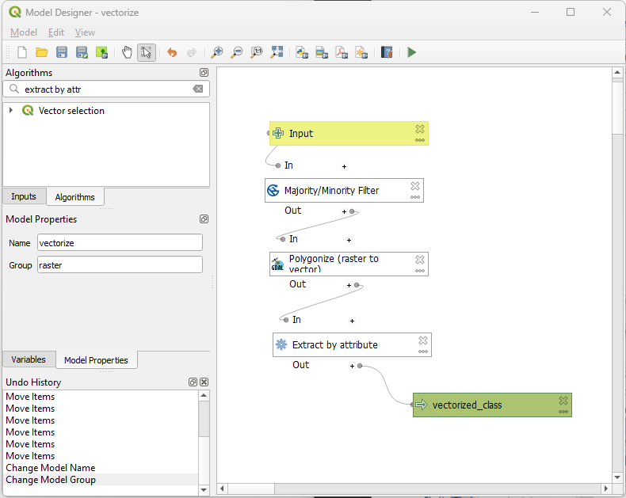

Step 11:- Now it is time to test our model. Close the modeler and switch to the main QGIS window. Go to Layer ‣ Add Layer ‣ Add Raster Layer....

Step 12:- Browse to the downloaded LC_hd_global_2001.tif.gz file and click Open. Once the raster is loaded, go to Processing ‣ Toolbox.

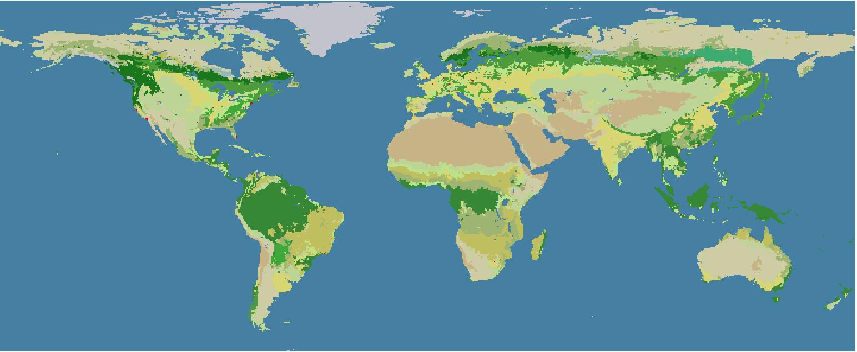

Step 13:- Find the newly created model under Models ‣ raster ‣ vectorize. Double-click to launch the model.

Step 14:- Select LC_hd_global_2001 as the Input and click Run.

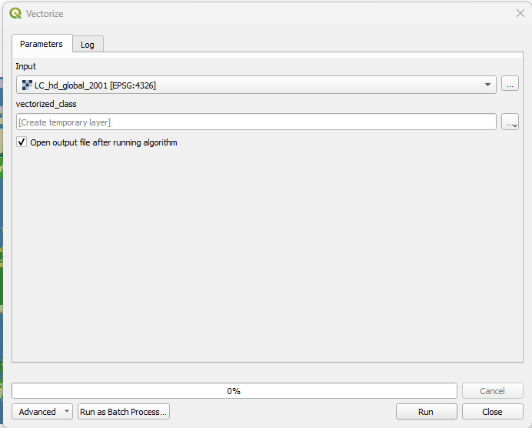

Step 15:- You will see all the steps being executed without any user input. Once the processing finishes, a new layer vectorized_classwill be added to QGIS. Let’s improve the model a little bit. Right- click on the vectorize model and select Edit model.

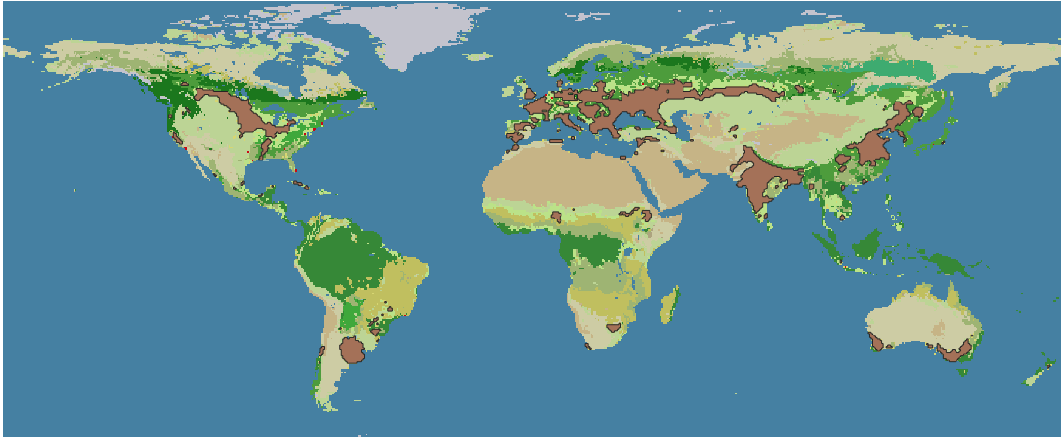

Step 16:- In Step 12, we hard-coded the value 12 as the class value. Instead, we can specify it as a input parameter which the user can change. To add this, switch to the Inputs tab and drag the + String to the model.

Step 17:- Enter the Parameter Name as Class. Enter 12 as the Default value.

Step 18:- We will now change the Extract by attribute algorithm to use this input instead of the hard- coded value. Click the Edit button next to the Extract by attribute box.

Step 19:- Click the dropdown arrow for Value and select Class. Click OK.

Step 20:- You will see from the model diagram that the Extract by attribute algorithm now uses 2 inputs. The modeler has a shortcut to launch the model and test it. Click the Run button from the toolbar.

Step 21:- Notice that the model dialog has a new editable field called Class. Enter 16 as the Class value and click Run.

Step 22:- Once the processing finishes, you will see that with just a click of a button we were able to run a complex workflow and extract the area for class 16.

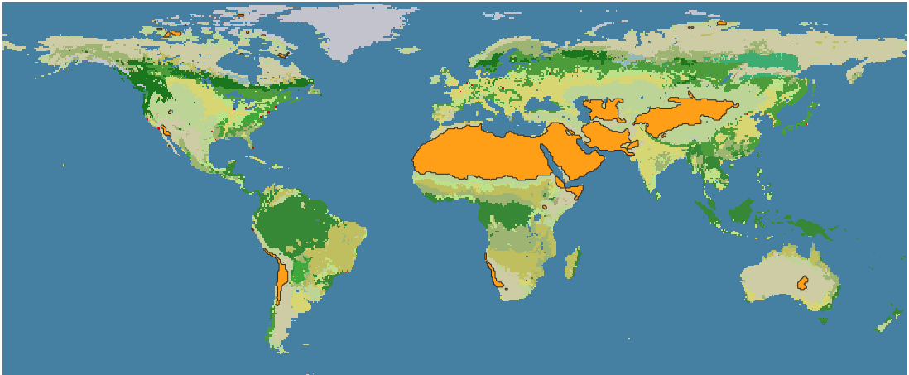

Step 23:- Now that our model is ready, we can run it just as easily on a new raster layer. Load the LC_hd_global_2012.tif.gz file by going to Layer ‣ Add Layer ‣ Add Raster Layer.... Click the vectorize` model from the Processing Toolbox panel.

Step 24:- Pick the LC_hd_global_2012 layer as the Input and click Run.

Step 25:- Once the new output is loaded, you can compare the changes in the Croplands from 2001 to 2012.